# 📝 **Rapport de TP – Robotique Mobile (TP1)**

**Étudiant :** Abdelali ichou **Groupe :** Group1, M2 ILA **Date :** 01-12-2025

# **1. Assemblage du robot**

### ✔️ Objectif

Assembler le robot mobile à partir des composants fournis : M5StickC Plus, RoverC, servomoteur, capteurs ToF, couleur, ultrasons, LEGO, câbles Grove.

### ✔️ Description

Le robot a été assemblé en suivant le livret fourni sur Moodle. Tous les modules ont été connectés à l’aide des ports Grove conformément aux instructions.

### 📸 *Photo de mon robot assemblé*

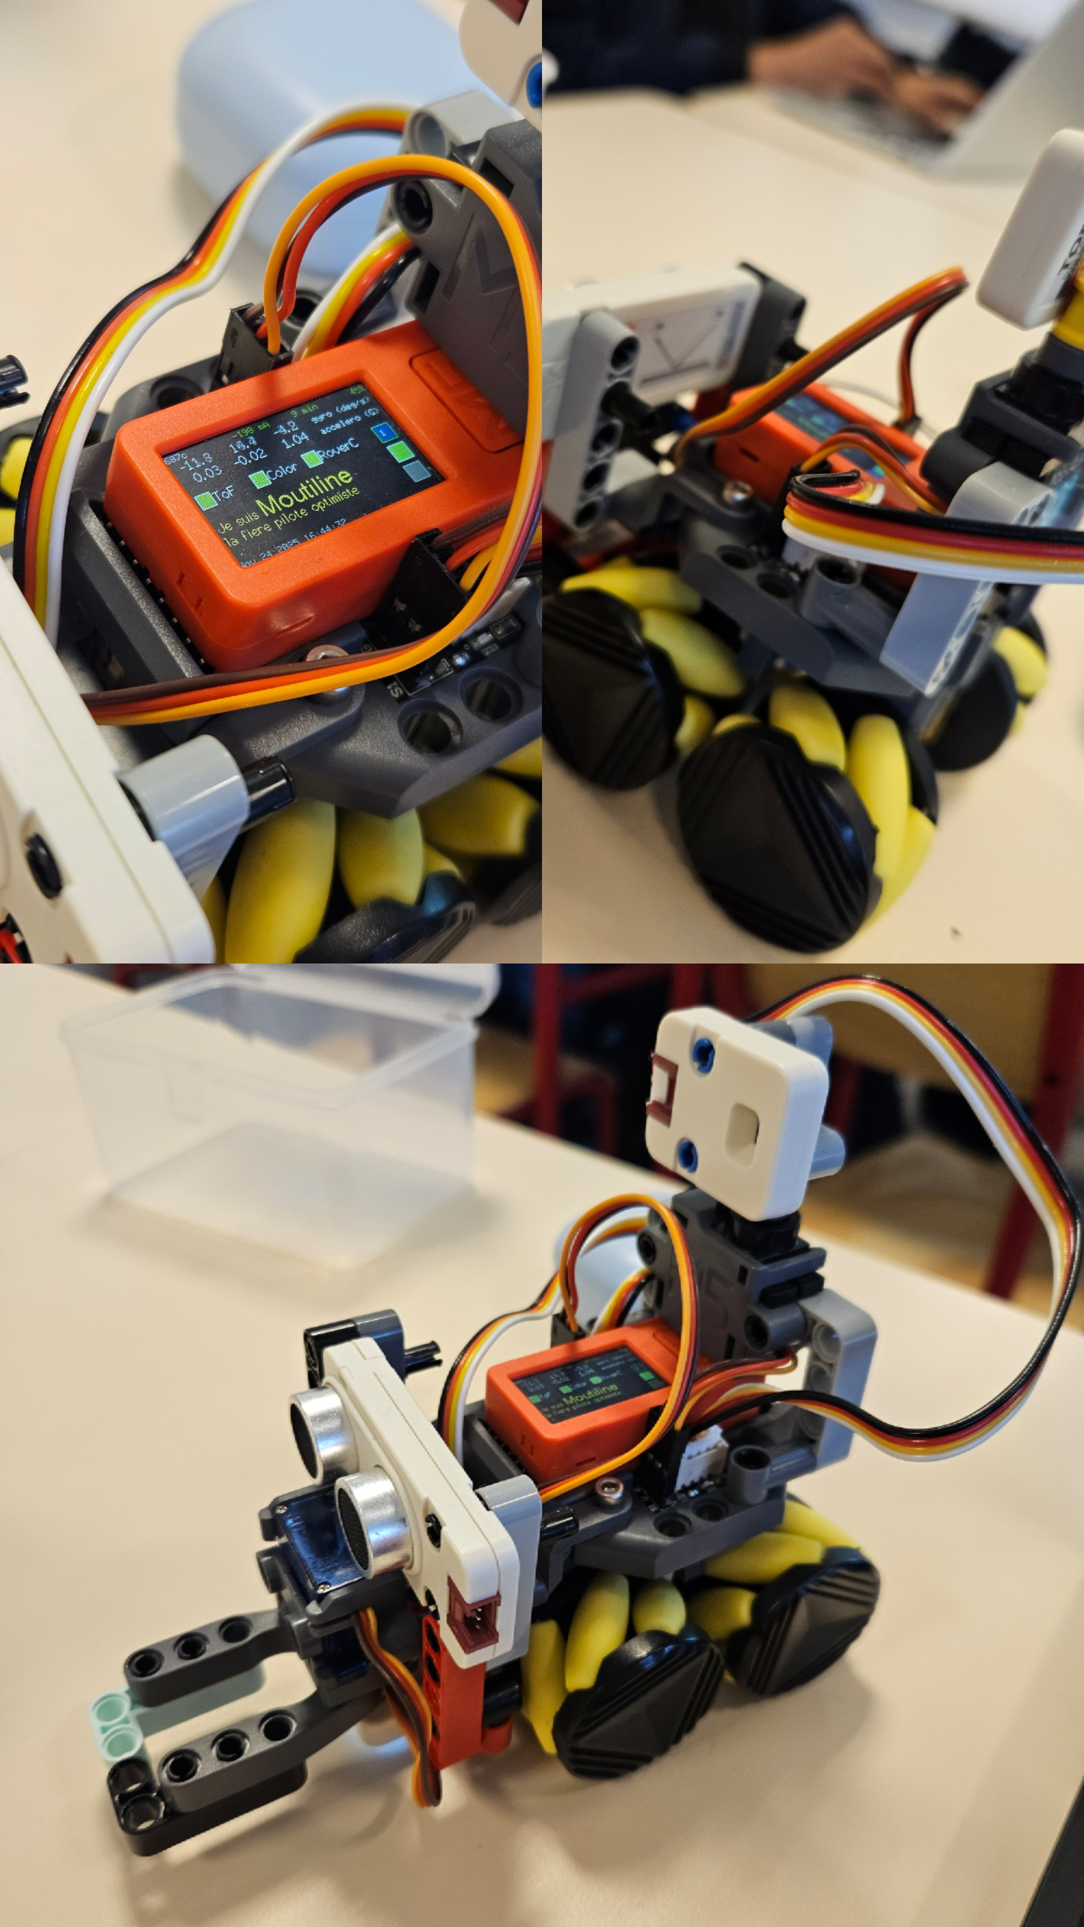

Robot assemblé

# **2. Mise en route du robot**

### ✔️ Allumage

* M5StickC Plus activé via le bouton arrière-gauche

### ✔️ Connexion WiFi

* Réseau : ROBM_Moulitine
* Mot de passe : WALL-E!SuzanCalvin

# **3. Utilisation de Pixi ROS2**

### ✔️ Démarrage de l’environnement ROS

pixi shell

### ✔️ Lancement du pont UDP

pixi run udp_bridge

Cette commande active la communication entre le robot et ROS2.

### 📸 *Capture d’écran : communication avec le robot*

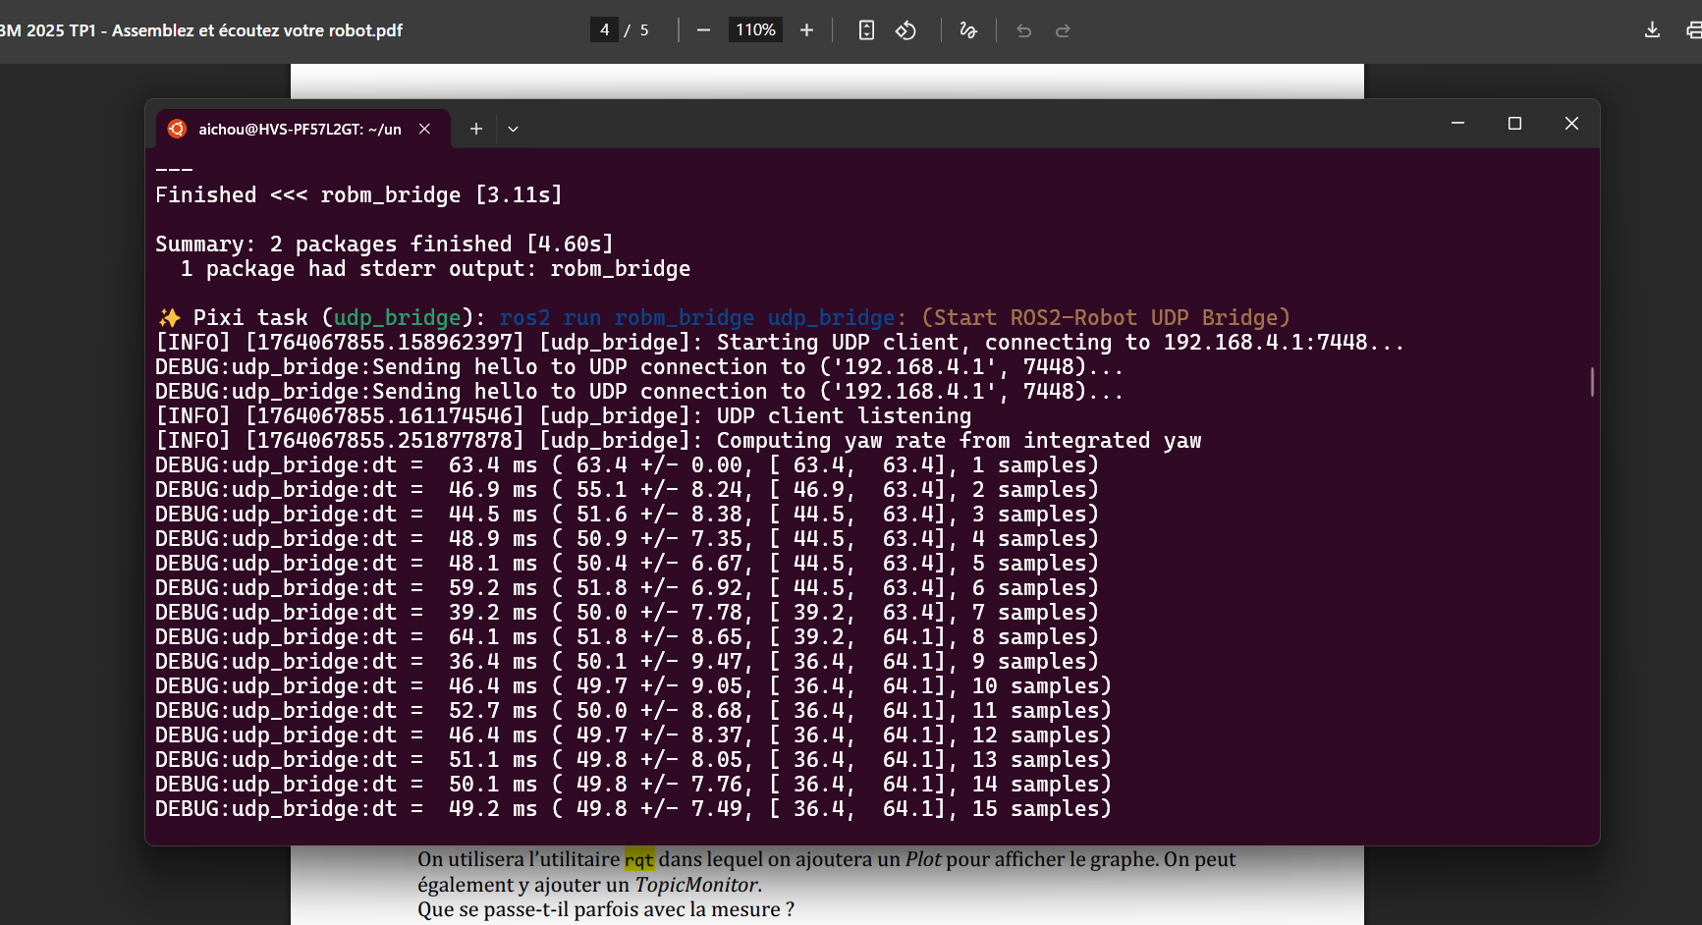

Topics list

# **4. Exploration des topics ROS2**

### ✔️ Liste des topics ROS2

Commande utilisée :

ros2 topic list

### 📸 *Capture d’écran : liste des topics*

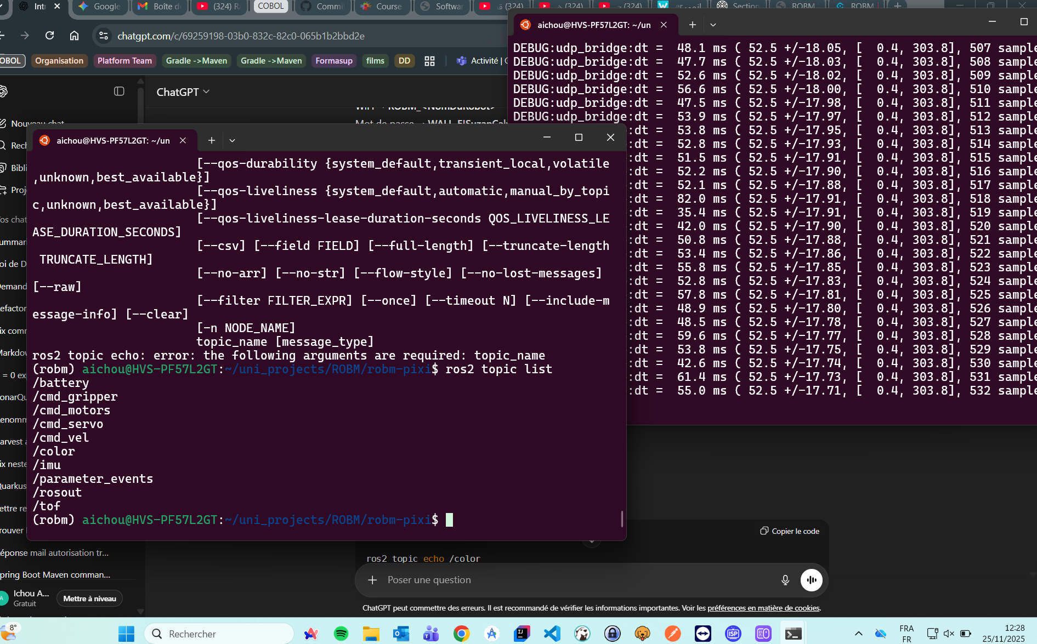

Topics list

# **5. Lecture des données des capteurs**

## **5.1 Capteur ToF (distance)**

### ✔️ Lecture des données

ros2 topic echo /tof

### 📸 *Capture d’écran : capture du distance*

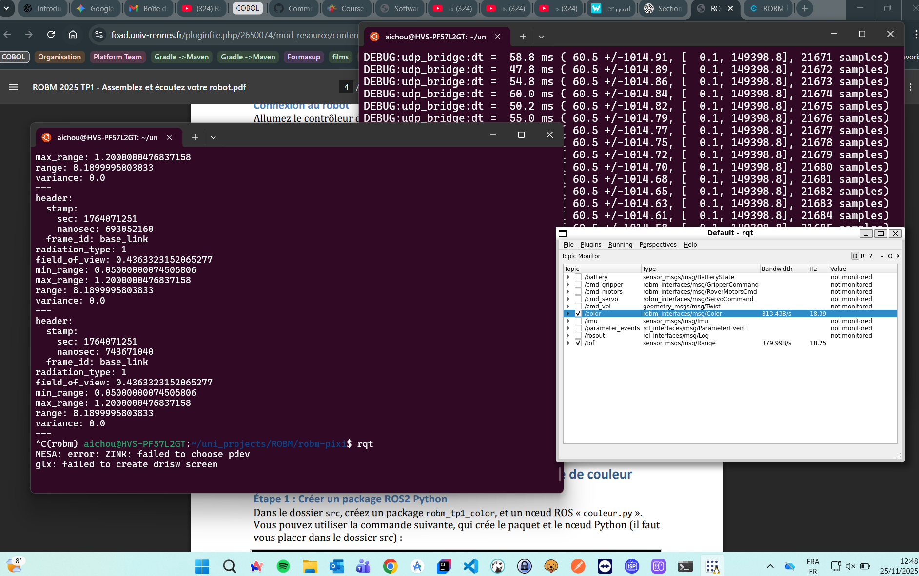

Topics list

### **Question : Que se passe-t-il parfois avec les mesures ?**

**Réponse :** Le capteur ToF renvoie parfois des valeurs incorrectes (0, très grandes valeurs). Cela se produit lorsque :

* l’objet est trop loin
* le capteur est trop proche de l’objet

### 📈 Affichage dans *rqt*

* Ajout d’un onglet Plugins/visualization/plot
* Ajout d’un topic/range

### 📸 *Capture d’écran du graphe ToF dans rqt GUI*

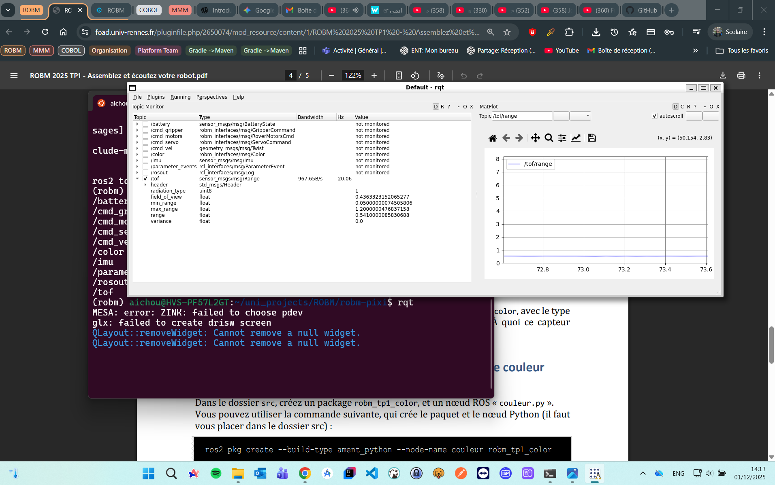

Topics list

## **5.2 Capteur Couleur**

### ✔️ Lecture des données

ros2 topic echo /color

### **Question : Quelles valeurs pour différents sols ?**

Voici mes mesures :

| Type de sol | R | G | B | Luminosité |
| --- | --- | --- | --- | --- |
| Bleu | 1 | 13 | 59 | 37 |
| Green | 6 | 32 | 12 | 210 |
| Rouge | 51 | 6 | 8 | 50 |

### 📸 *Capture d’écran du Rouge*

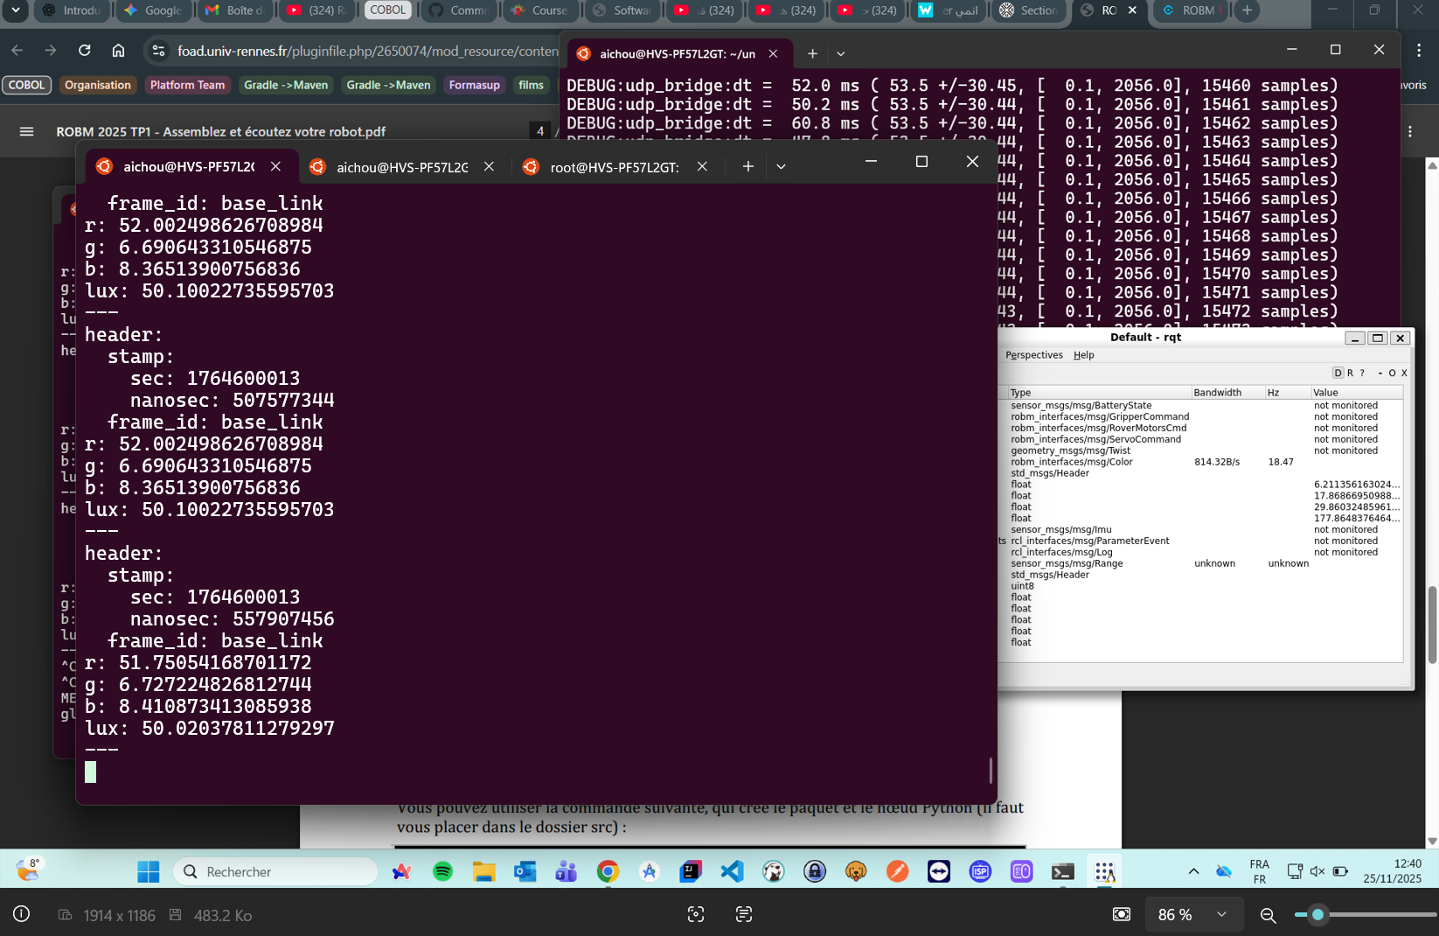

Topics list

### 📸 *Capture d’écran du Blue*

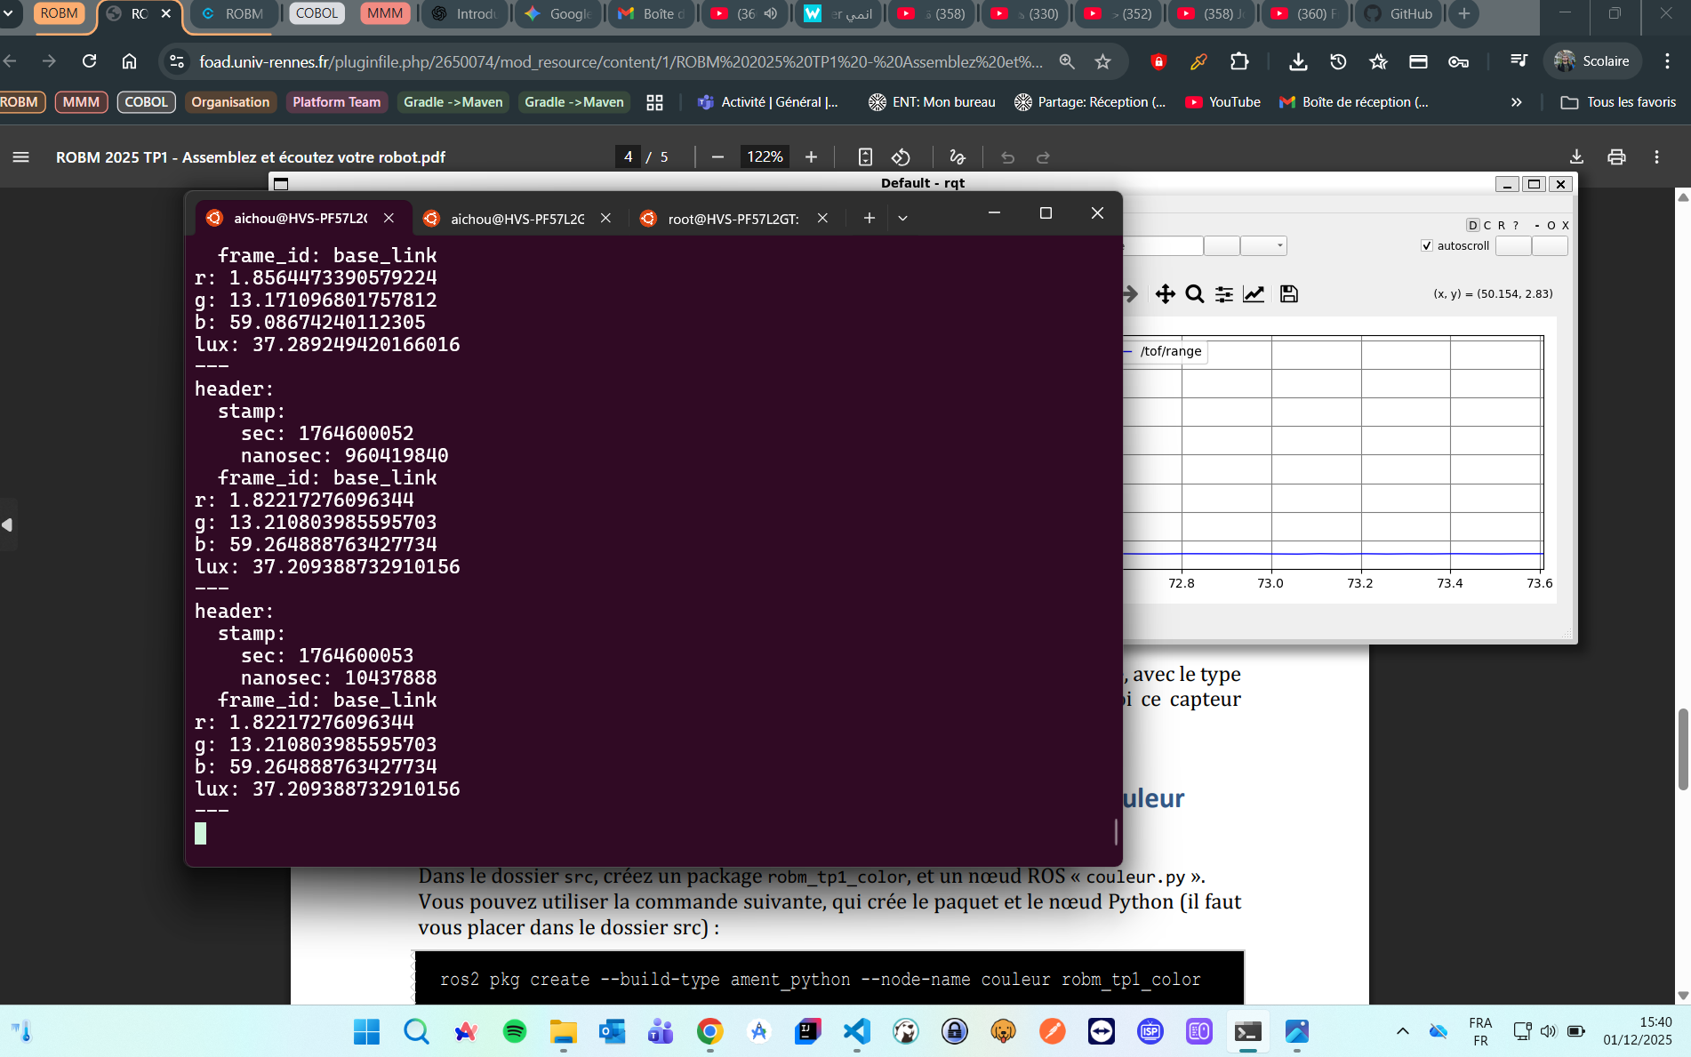

Topics list

### 📸 *Capture d’écran du Green*

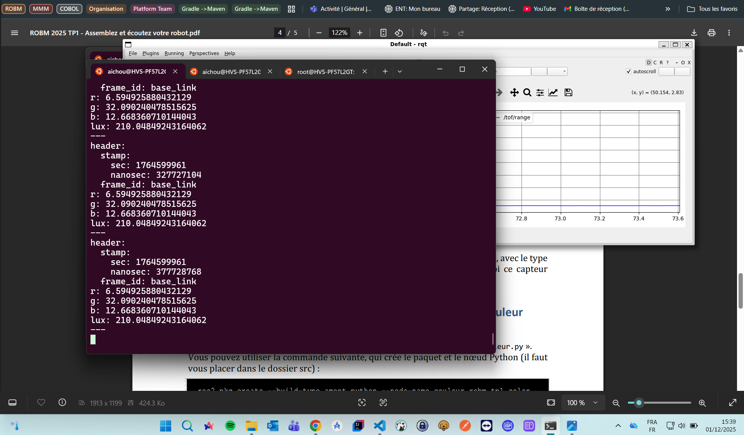

Topics list

### **Question : À quoi sert ce capteur ?**

**Réponse :**

* Reconnaissance de surfaces
* Détection de zones colorées

# **6. Développement d’un nœud ROS2 : Détection de couleur**

## **6.1 Création du package**

Commande utilisée :

cd src

ros2 pkg create --build-type ament_python --node-name couleur robm_tp1_color

cd ..

colcon build or pixi run build

source install/setup.bash

### 📸 *Capture de l’arborescence du package*

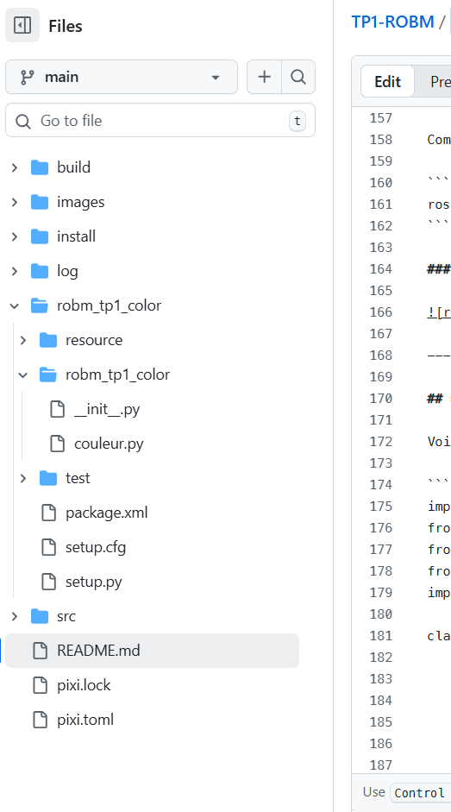

rborescence package

## **6.2 Code du nœud : abonnement au capteur couleur**

Voici le code utilisé :

import rclpy  
from rclpy.node import Node  
from robm_interfaces.msg import Color  
from std_msgs.msg import String  
import numpy as np  
  
class ColorDetector(Node):  
 def __init__(self):  
 super().__init__('couleur')  
  
 self.subscription = self.create_subscription(  
 Color,  
 'color',  
 self.callback_color,  
 10  
 )  
  
 self.publisher = self.create_publisher(String, 'nom_couleur', 10)  
  
 # Valeurs des couleurs mesurées auparavant  
 self.known_colors = {  
 "blanc": np.array([200, 200, 200]),  
 "noir": np.array([10, 10, 10]),  
 "rouge": np.array([180, 40, 30]),  
 "vert": np.array([40, 180, 40]),  
 "bleu": np.array([30, 40, 180])  
 }  
  
 def callback_color(self, msg):  
 current = np.array([msg.r, msg.g, msg.b])  
  
 distances = {name: np.linalg.norm(current - ref)  
 for name, ref in self.known_colors.items()}  
  
 detected = min(distances, key=distances.get)  
  
 msg_out = String()  
 msg_out.data = detected  
 self.publisher.publish(msg_out)  
  
 self.get_logger().info(f"Couleur détectée : {detected}")  
  
def main(args=None):  
 rclpy.init(args=args)  
 node = ColorDetector()  
 rclpy.spin(node)  
 node.destroy_node()  
 rclpy.shutdown()

## **6.3 Test du nœud**

### ✔️ Lancement

pixi shell

cd ~/uni_projects/ROBM/robm-pixi

colcon build or pixi run build

source install/setup.bash

ros2 run robm_tp1_color couleur

### ✔️ Observation du topic :

ros2 topic echo /nom_couleur

### 📸 *Capture : topic nom_couleur*

![nom_couleur](CHEMIN_VERS_L_IMAGE)

# **7. Visualisation du réseau ROS : rqt_graph**

rqt_graph

Le schéma attendu :

/color ---> /couleur ---> /nom_couleur

### 📸 *Capture d’écran du graphe ROS2*

![rqt_graph](CHEMIN_VERS_L_IMAGE)

# **8. Problèmes rencontrés**

* difficultés de connexion WiFi
* erreur Python dans le package (ex : rclpy)
* capteur ToF instable
* problème avec rqt qui ne rafraîchit pas & très lent

# **9. Conclusion**

Ce TP m’a permis de :

* comprendre & manipuler ROS2 (topics, publishers, subscribers)
* utiliser *rqt* pour visualiser des données
* développer un nœud ROS2 fonctionnel de détection de couleur
* publier un message personnalisé sur un topic

# 📝 Notes:

### Démarrage de l’environnement ROS

pixi shell

### Lancement du bridge UDP avec le robot

**You need to be inside shell**

pixi shell

ros2 run robm_bridge udp_bridge

### Show all avaible topics with the robot

ros2 topic list

### Read data from a topic

ros2 topic echo /topic

ros2 topic echo /color

ros2 topic echo /tof

### Creating new topic package

cd src (obligatory, so it will be created along side with the robm_interfaces)

ros2 pkg create --build-type ament_python --node-name Python_noeud_file Topic_package_name

cd ..

colcon build or pixi run build

source install/setup.bash

### Inside our Python_noeud_file, we susbsribe to the color topic to receive color data from the robot

self.subscription = self.create_subscription(  
 Color,  
 'color',  
 self.color_callback,  
 10  
)

### Publish the real time sensor color to a topic

self.publisher = self.create_publisher(String, 'topic_name', 10)

self.publisher.publish("message")

### Running the Python_noeud_file in terminal N1

pixi shell

cd ~/uni_projects/ROBM/robm-pixi

colcon build or pixi run build

source install/setup.bash

ros2 run Topic_package_name Python_noeud_file

### Consuming the Python_noeud_file topic in terminal N2

if we show all the topics, we will se the one created by the package we runned in the previous command

ros2 topic list

We consume this previous created topic

pixi shell

cd ~/uni_projects/ROBM/robm-pixi

ros2 topic echo /topic_name

# 📝 **Rapport de TP – Robotique Mobile (TP2)**

**Étudiant :** Abdelali ichou **Groupe :** Group1, M2 ILA **Date :** 01-12-2025

### Configuration du réparation

Mettre à jour le sous-module ROS Pixi

cd pixi home

git submodule update --init --recursive --remote

Installer teleop_tools (pour contrôler avec clavier/souris) :

cd <home>/src

git clone https://github.com/ros-teleop/teleop_tools.git

cd ..

pixi shell

colcon build or pixi run build

source install/setup.bash

Connexion au robot dans un autre terminal :

pixi shell

ros2 run robm_bridge udp_bridge

### Créer le package ROS2 pour le TP2

cd <home>/src

Créer le package Python

ros2 pkg create --build-type ament_python --node-name avance_motor robm_tp2_move

cd ..

pixi shell

colcon build or pixi run build

source install/setup.bash

### Comprendre le message de commande des moteurs

Topic : cmd_motors

Type : robm_interfaces/msg/RoverMotorsCmd

| Champ | Signification | Valeur |
| --- | --- | --- |
| front_left | moteur avant gauche | -1 à 1 |
| front_right | moteur avant droit | -1 à 1 |
| rear_left | moteur arrière gauche | -1 à 1 |
| rear_right | moteur arrière droit | -1 à 1 |

-1 → plein arrière, 1 → plein avant

Contrôle PWM → il faut envoyer les commandes régulièrement pour maintenir le mouvement

### Code de nœud Python : avance_motor.py

import rclpy  
from rclpy.node import Node  
from robm_interfaces.msg import RoverMotorsCmd  
  
class AvanceMotor(Node):  
 def __init__(self):  
 super().__init__('avance_motor')  
  
 # Publisher vers cmd_motors  
 self.publisher = self.create_publisher(RoverMotorsCmd, 'cmd_motors', 10)  
  
 # Timer à 10 Hz  
 self.counter = 0  
 self.max_count = 20 # 20 messages → 2 secondes  
 self.timer = self.create_timer(0.1, self.timer_callback) # 0.1s = 10Hz  
  
 def timer_callback(self):  
 if self.counter < self.max_count:  
 msg = RoverMotorsCmd()  
 # Déplacement avant : tous moteurs à +0.5  
 msg.front_left = 0.5  
 msg.front_right = 0.5  
 msg.rear_left = 0.5  
 msg.rear_right = 0.5  
  
 self.publisher.publish(msg)  
 self.get_logger().info(f"Commande moteur envoyée ({self.counter+1}/{self.max_count})")  
 self.counter += 1  
 else:  
 # Stop le robot après 2 secondes  
 msg = RoverMotorsCmd()  
 msg.front_left = 0.0  
 msg.front_right = 0.0  
 msg.rear_left = 0.0  
 msg.rear_right = 0.0  
 self.publisher.publish(msg)  
 self.get_logger().info("Arrêt du robot.")  
 self.timer.cancel()  
  
def main(args=None):  
 rclpy.init(args=args)  
 node = AvanceMotor()  
 rclpy.spin(node)  
 node.destroy_node()  
 rclpy.shutdown()  
  
if __name__ == '__main__':  
 main()

### Test du nœud

Lancer udp_bridge dans un terminal1

pixi shell

ros2 run robm_tp2_move avance_motor

Visualiser le réseau ROS2

rqt_graph

### Créer d’autres mouvements

Tourne sur place : tourne_motor.py

msg.front_left = -0.5  
msg.front_right = 0.5  
msg.rear_left = -0.5  
msg.rear_right = 0.5

Tourner à gauche : gauche_motor.py

msg.front_left = -0.5  
msg.front_right = 0.5  
msg.rear_left = 0.5  
msg.rear_right = -0.5

Tourner à droit : droit_motor.py

msg.front_left = 0.5  
msg.front_right = -0.5  
msg.rear_left = -0.5  
msg.rear_right = 0.5

Marche arrière : back_motor.py

msg.front_left = -1.0  
msg.front_right = -1.0  
msg.rear_left = -1.0  
msg.rear_right = -1.0

Marche avant : avance_motor.py

msg.front_left = 0.5  
msg.front_right = 0.5  
msg.rear_left = 0.5  
msg.rear_right = 0.5

Inside setup.py we add the shell commands

entry_points={  
 'console_scripts': [  
 'avance_motor = robm_tp2_move.avance_motor:main',  
 'gauche_motor = robm_tp2_move.gauche_motor:main',  
 'tourne_motor = robm_tp2_move.tourne_motor:main',  
 'back_motor = robm_tp2_move.back_motor:main',  
 'droit_motor = robm_tp2_move.droit_motor:main',  
 ],  
 },

Maintenant, tu peux lancer tes trois nœuds avec :

ros2 run robm_tp2_move avance_motor

### 📸 *Capture d’écran du Robot avance*

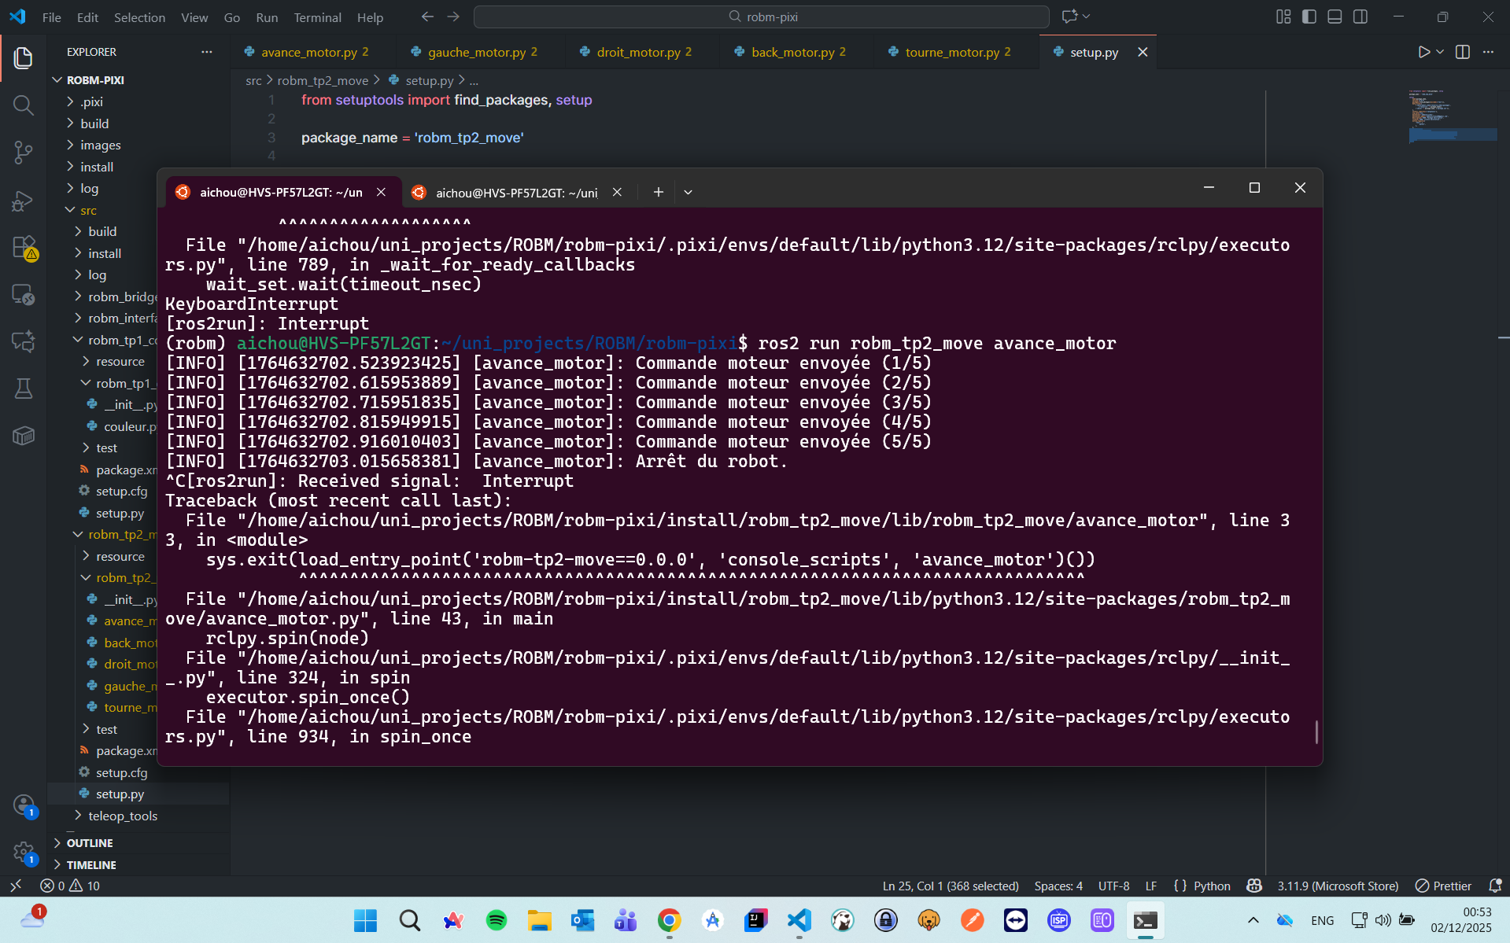

Robot movement

ros2 run robm_tp2_move back_motor

### 📸 *Capture d’écran du Robot back*

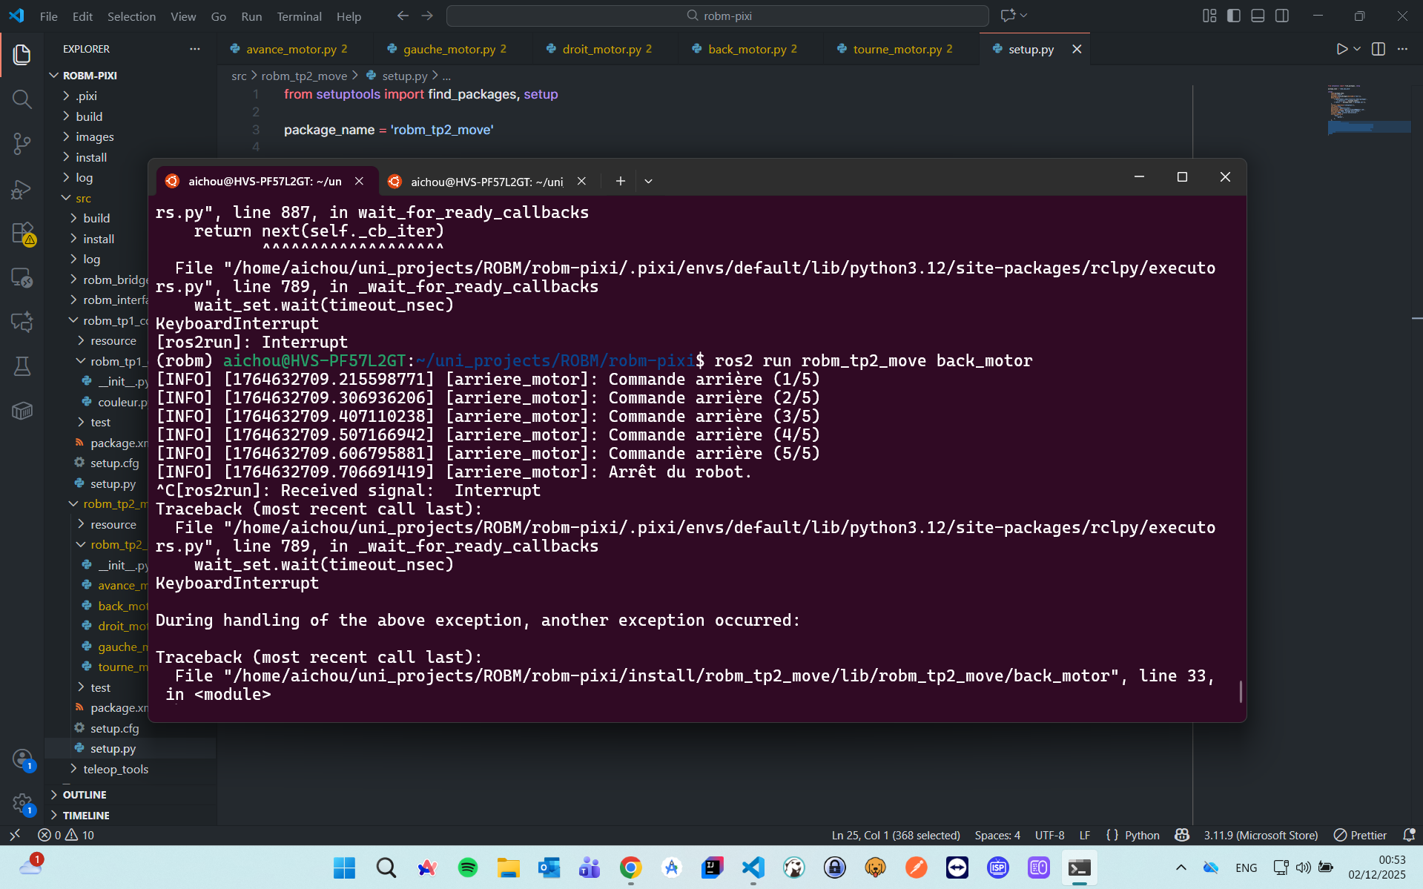

Robot movement

ros2 run robm_tp2_move droit_motor

### 📸 *Capture d’écran du Robot droit*

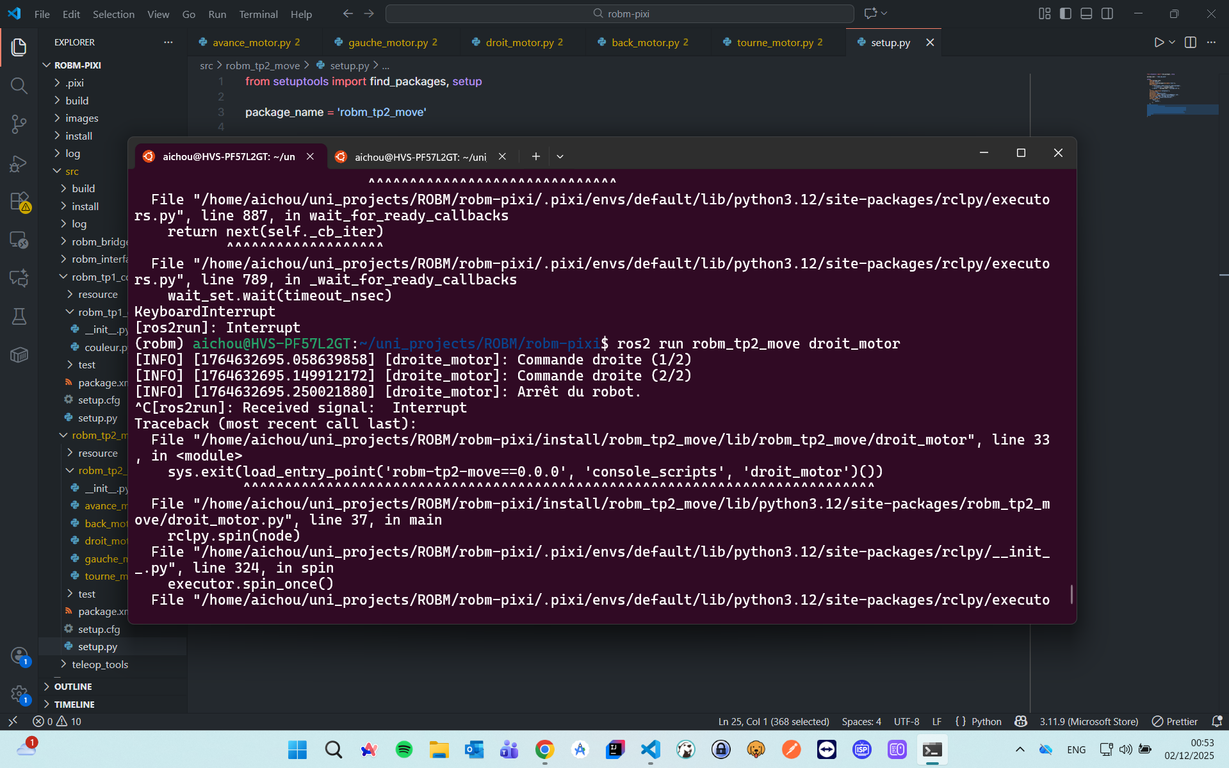

Robot movement

ros2 run robm_tp2_move gauche_motor

### 📸 *Capture d’écran du Robot gauche*

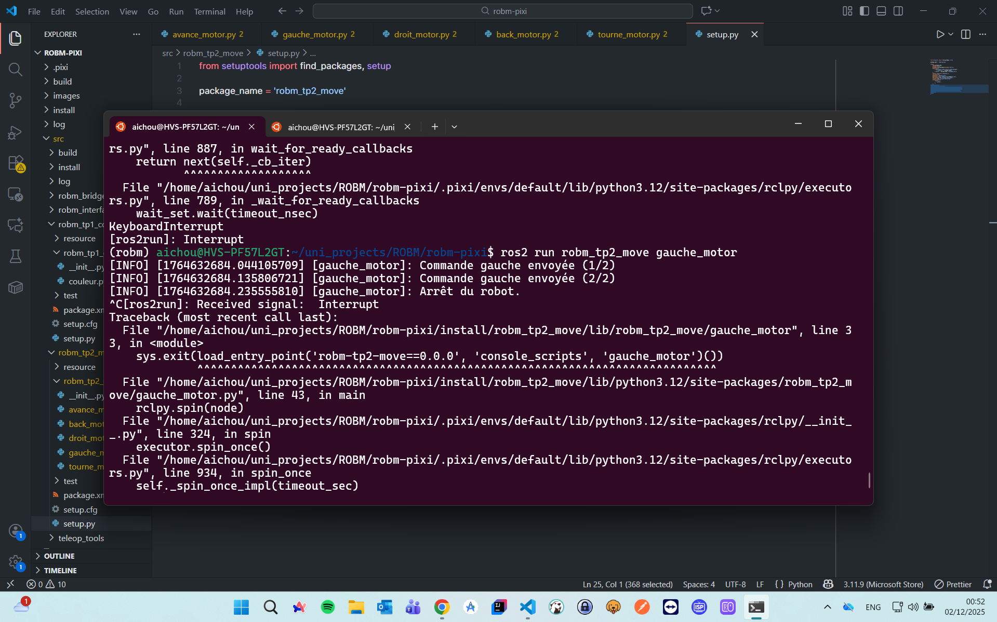

Robot movement

ros2 run robm_tp2_move tourne_motor

### 📸 *Capture d’écran du Robot tourne*

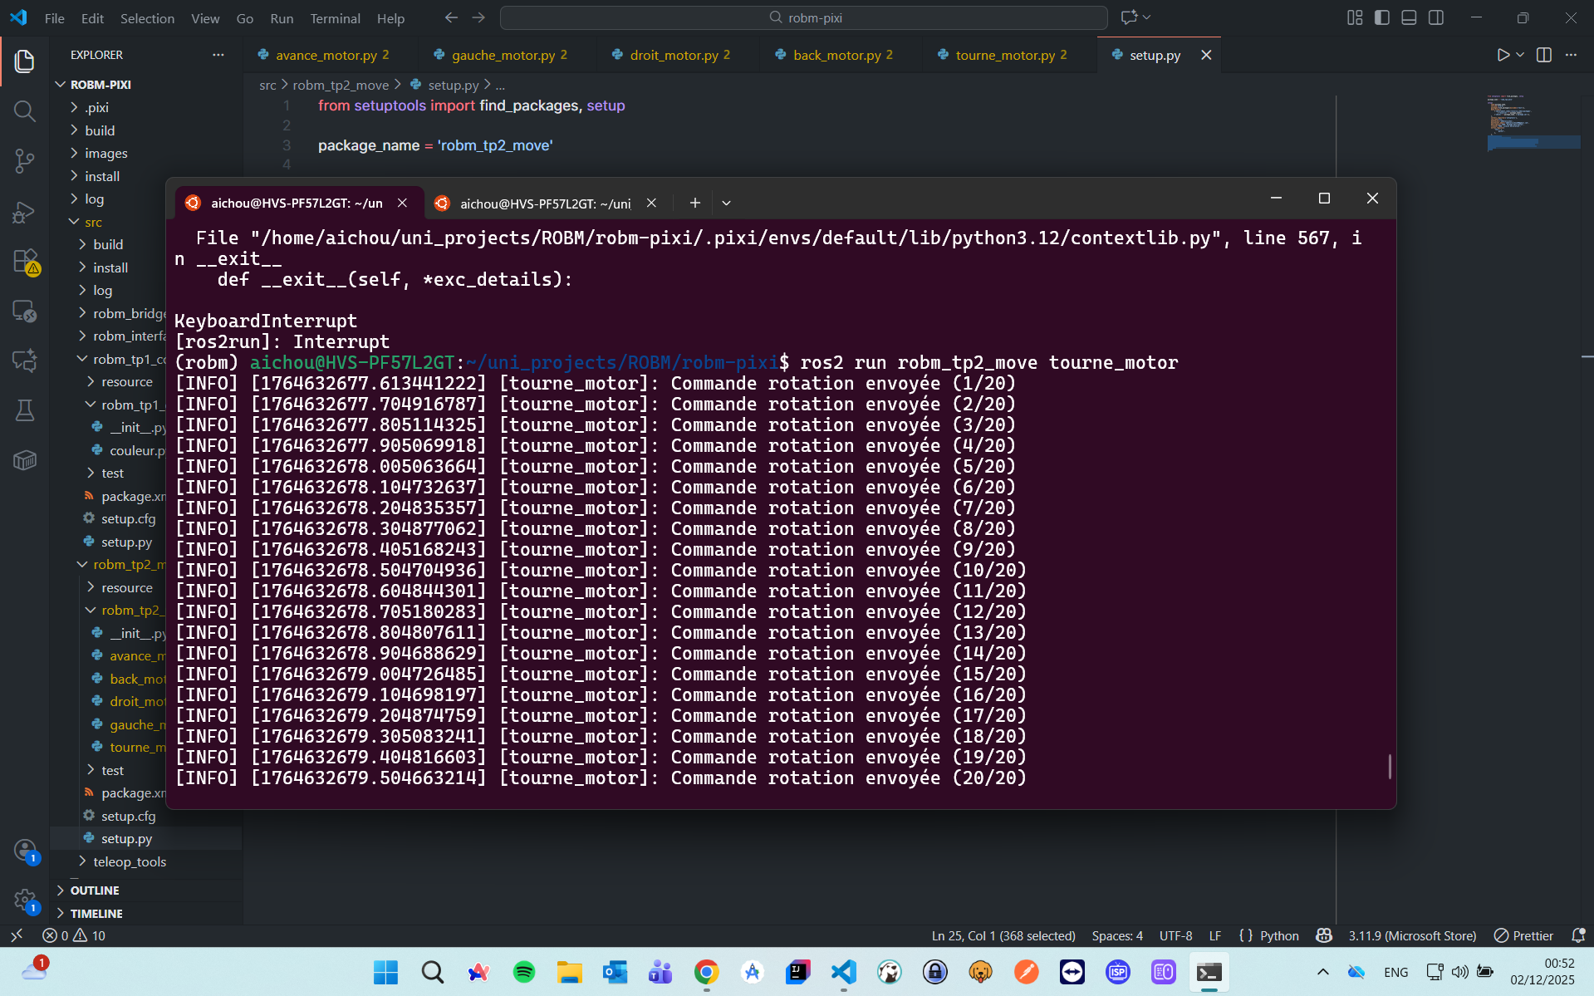

Robot movement

### Move robot with keyboard

create the new movement python node

import rclpy  
from rclpy.node import Node  
from geometry_msgs.msg import TwistStamped  
from robm_interfaces.msg import RoverMotorsCmd  
  
class VelToMotor(Node):  
 """Converts TwistStamped messages into individual motor commands."""  
  
 def __init__(self):  
 super().__init__('vel_to_motor')  
 self.get_logger().info("Node started: converting velocities to motor commands.")  
  
 # Subscriber to cmd_vel or any TwistStamped topic  
 self.sub = self.create_subscription(  
 TwistStamped,  
 'vel', # topic to subscribe to (you can remap key_teleop output)  
 self.vel_callback,  
 10  
 )  
  
 # Publisher to cmd_motors  
 self.pub = self.create_publisher(RoverMotorsCmd, 'cmd_motors', 10)  
  
 def vel_callback(self, msg: TwistStamped):  
 """Convert linear and angular velocities to motor commands."""  
 # Extract velocities  
 vx = msg.twist.linear.x # forward/back  
 vy = msg.twist.linear.y # left/right  
 wz = msg.twist.angular.z # rotation  
  
 # Compute each wheel command for Mecanum robot  
 motor_cmd = RoverMotorsCmd()  
 motor_cmd.front_left = vx - vy - wz  
 motor_cmd.front_right = vx + vy + wz  
 motor_cmd.rear_left = vx + vy - wz  
 motor_cmd.rear_right = vx - vy + wz  
  
 # Ensure values are within [-1, 1] for motor driver  
 motor_cmd.front_left = max(-1.0, min(1.0, motor_cmd.front_left))  
 motor_cmd.front_right = max(-1.0, min(1.0, motor_cmd.front_right))  
 motor_cmd.rear_left = max(-1.0, min(1.0, motor_cmd.rear_left))  
 motor_cmd.rear_right = max(-1.0, min(1.0, motor_cmd.rear_right))  
  
 # Publish motor command  
 self.pub.publish(motor_cmd)  
 self.get_logger().info(  
 f"Motors cmd | FL:{motor_cmd.front_left:.2f} FR:{motor_cmd.front_right:.2f} "  
 f"RL:{motor_cmd.rear_left:.2f} RR:{motor_cmd.rear_right:.2f}"  
 )  
  
  
def main(args=None):  
 rclpy.init(args=args)  
 node = VelToMotor()  
 rclpy.spin(node)  
 node.destroy_node()  
 rclpy.shutdown()  
  
  
if __name__ == "__main__":  
 main()

in the first terminal

ros2 run robm_tp2_move dynamic_motor

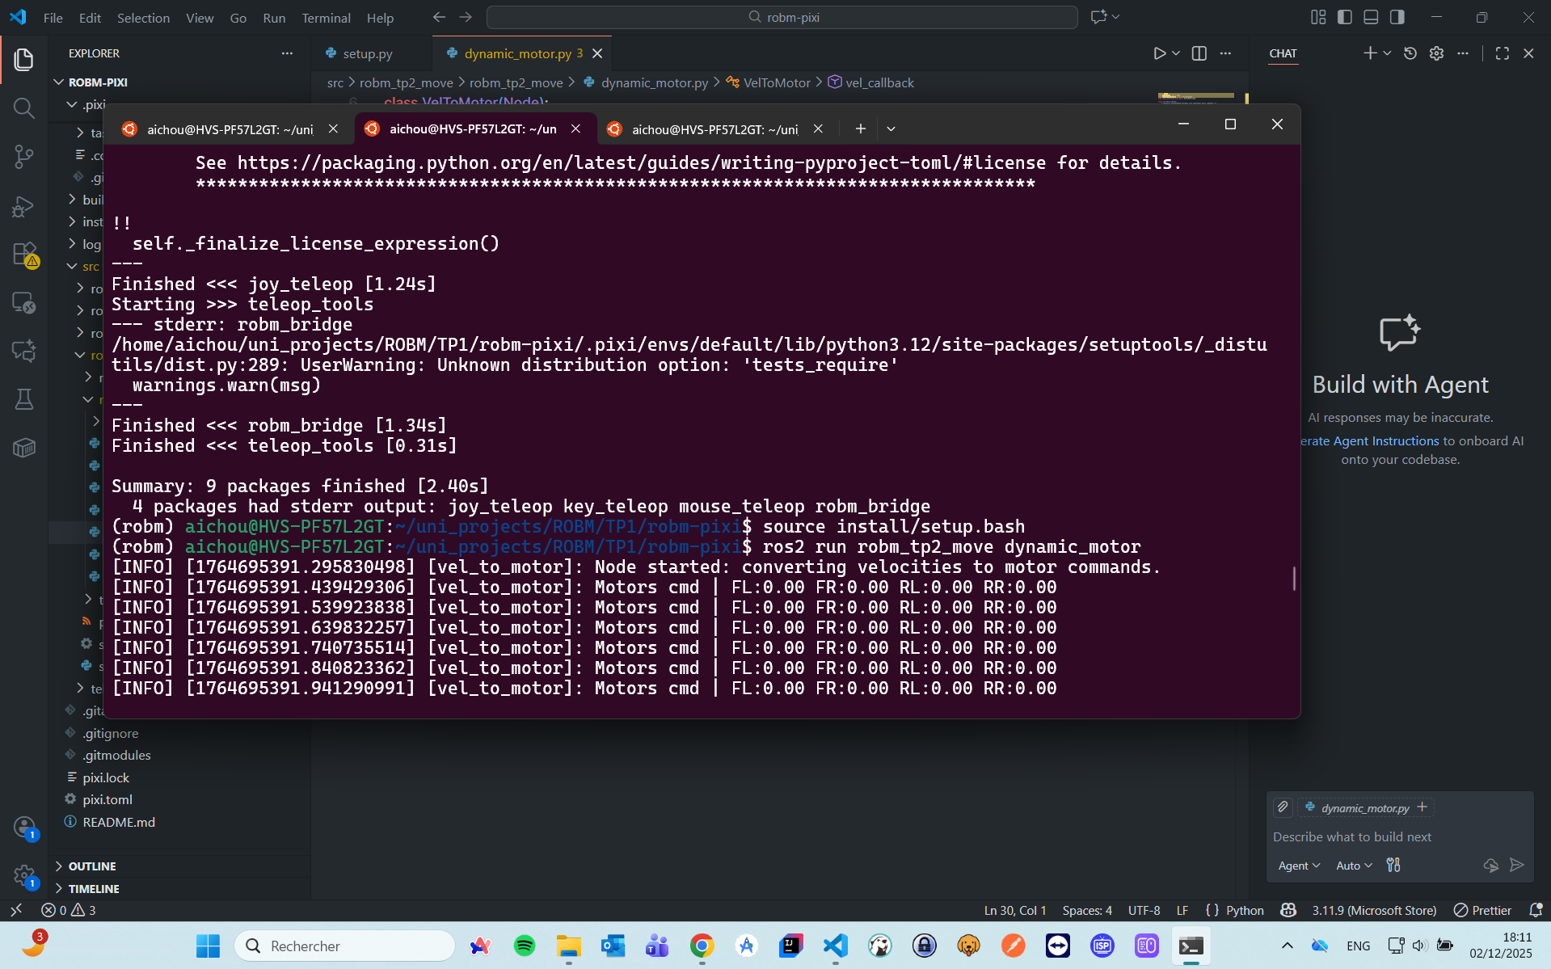

Robot movement

in the second terminal

ros2 run key_teleop key_teleop --ros-args -p rotation_rate:=0.5 -r key_vel:=vel

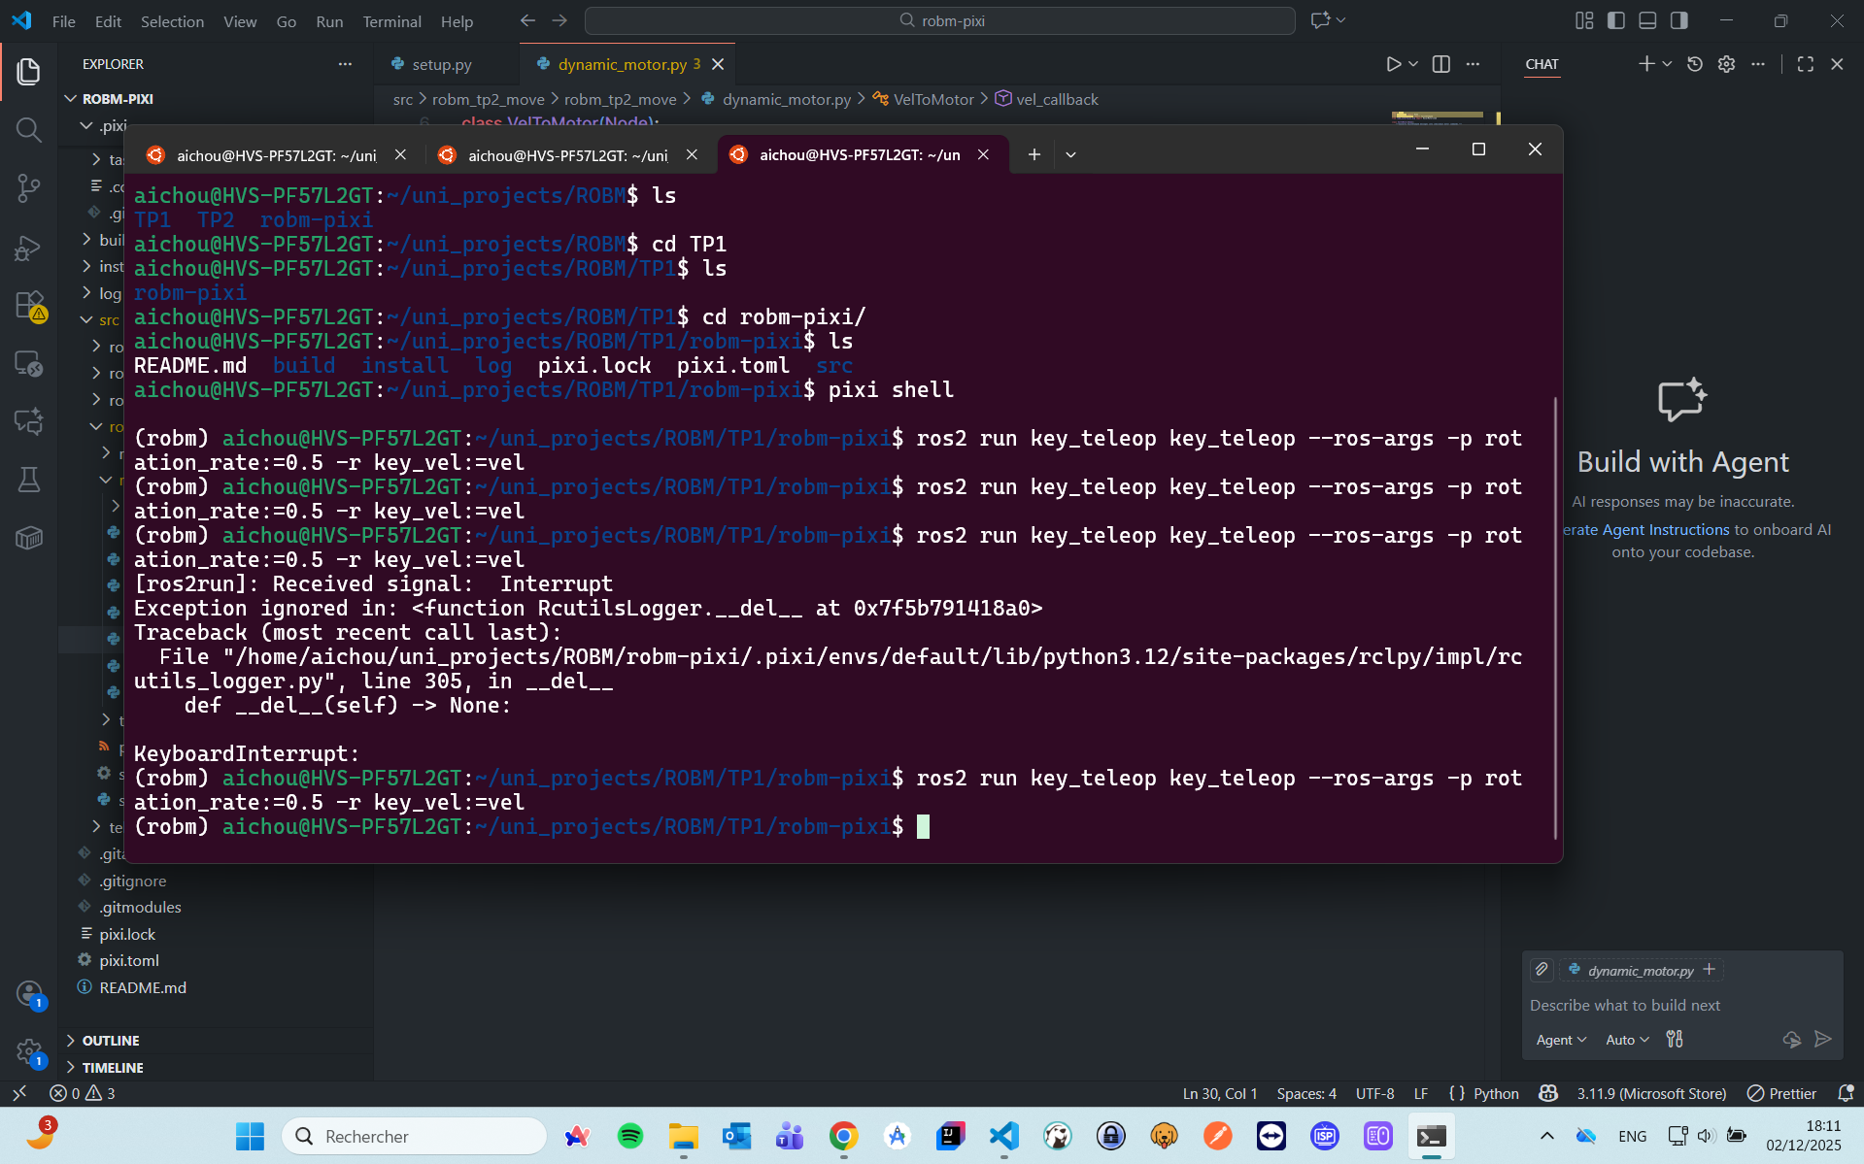 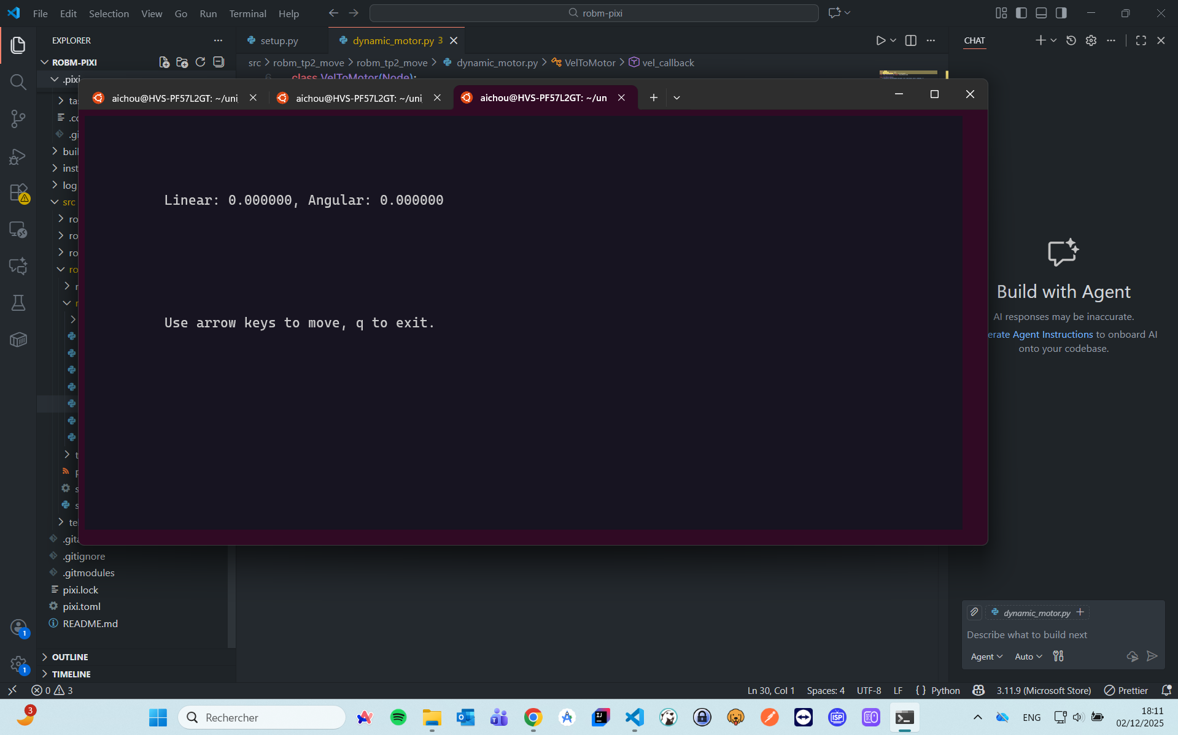

### Move robot with keyboard

We will the predefined keyboard commands, we dont need to run our 3rd script

ros2 run key_teleop key_teleop --ros-args -p rotation_rate:=0.5 -r key_vel:=cmd_vel



Robot movement

### Move robot with Mouse

ros2 run mouse_teleop mouse_teleop --ros-args -p holonomic:=True -p frequency:=10.0 -r mouse_vel:=cmd_vel

# 📝 **Rapport de TP – Robotique Mobile (TP3)**

**Étudiant :** Abdelali ichou **Groupe :** Group1, M2 ILA **Date :** 07-12-2025

### Sop on the wall command

ros2 run robm_tp3_roomba collision

iimport rclpy  
from rclpy.node import Node  
  
from geometry_msgs.msg import TwistStamped  
from sensor_msgs.msg import Range  
  
  
class Anticollision(Node):  
 """Improved anticollision with smoother, slower behavior and 90° turn."""  
 def __init__(self):  
 super().__init__('anticollision')  
  
 self.sub_tof = self.create_subscription(  
 Range, 'tof', self.tof_callback, 10  
 )  
  
 self.pub_vel = self.create_publisher(TwistStamped, 'cmd_vel', 10)  
  
 # Slower timer → smoother reactions (10 Hz instead of 20 Hz)  
 self.timer = self.create_timer(0.1, self.timer_callback)  
  
 self.current_range = None  
  
 # For smooth speed change  
 self.current_speed = 0.0  
  
 def tof_callback(self, msg: Range):  
 """Save distance from TOF sensor."""  
 self.current_range = msg.range  
  
 def timer_callback(self):  
 msg = TwistStamped()  
 msg.header.stamp = self.get_clock().now().to_msg()  
 msg.header.frame_id = 'base_link'  
  
 if self.current_range is None:  
 msg.twist.linear.x = 0.0  
 self.pub_vel.publish(msg)  
 return  
  
 d = self.current_range  
  
 # ===== NEW THRESHOLDS =====  
 safe_distance = 0.80 # Start slowing earlier  
 stop_distance = 0.30 # At this distance → turn left  
  
 # ===== NEW SPEEDS =====  
 max_speed = 0.20 # Much slower  
 min_speed = 0.05  
  
 # ===== Behavior rules =====  
  
 # 1) Obstacle extremely close → turn LEFT 90°  
 if d < stop_distance:  
 msg.twist.linear.x = 0.0  
 msg.twist.angular.z = 1.2 # turn left smoothly  
 self.pub_vel.publish(msg)  
 self.get_logger().info("TOO CLOSE → Turning left")  
 return  
  
 # 2) Between stop_distance and safe_distance → slow down  
 if stop_distance <= d < safe_distance:  
 # Linear scale from max_speed → min_speed  
 speed = min_speed + (max_speed - min_speed) * ((d - stop_distance) / (safe_distance - stop_distance))  
 else:  
 # 3) Far away → full slow speed  
 speed = max_speed  
  
 # Smooth motion (avoid jerky behavior)  
 alpha = 0.2 # smoothing factor  
 self.current_speed = alpha * speed + (1 - alpha) * self.current_speed  
  
 # Apply forward speed  
 msg.twist.linear.x = float(self.current_speed)  
 msg.twist.angular.z = 0.0  
  
 self.pub_vel.publish(msg)  
 self.get_logger().info(f"Distance: {d:.2f} m → vx: {self.current_speed:.2f}")  
  
  
def main(args=None):  
 rclpy.init(args=args)  
 node = Anticollision()  
 rclpy.spin(node)  
 node.destroy_node()  
 rclpy.shutdown()  
  
  
if __name__ == '__main__':  
 main()

### Stop on the wall and change direction command

ros2 run robm_tp3_roomba anticollision

import rclpy  
from rclpy.node import Node  
  
from geometry_msgs.msg import TwistStamped  
from sensor_msgs.msg import Range  
  
  
class Anticollision(Node):  
 """Move forward, slow down near walls, reverse when too close."""  
  
 def __init__(self):  
 super().__init__('anticollision')  
  
 # Subscribe to ToF sensor ("tof")  
 self.sub_tof = self.create_subscription(  
 Range,  
 'tof',  
 self.tof_callback,  
 10  
 )  
  
 # Publish TwistStamped to cmd_vel  
 self.pub_vel = self.create_publisher(  
 TwistStamped,  
 'cmd_vel',  
 10  
 )  
  
 # Timer: 20 Hz  
 self.timer = self.create_timer(0.05, self.timer_callback)  
  
 # Last measured distance (meters)  
 self.current_range = 1.0 # default = safe distance  
  
 self.get_logger().info("Anticollision node started.")  
  
 # -------------------------------  
 # TOF CALLBACK  
 # -------------------------------  
 def tof_callback(self, msg: Range):  
 """Save the measured range from the ToF sensor."""  
 self.current_range = msg.range # <-- real distance in meters  
  
 # -------------------------------  
 # CONTROL LOOP (20 Hz)  
 # -------------------------------  
 def timer_callback(self):  
 msg = TwistStamped()  
 msg.header.stamp = self.get_clock().now().to_msg()  
 msg.header.frame_id = 'base_link'  
  
 d = self.current_range # short alias  
  
 # --- BEHAVIOR RULES ---  
 if d > 0.50:  
 # Normal forward speed (0.3 m/s)  
 vx = 0.2  
  
 elif 0.20 < d <= 0.50:  
 # Slow down linearly  
 # when d = 0.50 → vx = 0.30  
 # when d = 0.20 → vx = 0.00  
 vx = 0.30 * (d - 0.20) / (0.50 - 0.20)  
  
 else:  
 # d < 0.20 → reverse proportionally  
 # when d = 0.20 → 0.0  
 # when d = 0.05 → -0.25 (example)  
 min_dist = 0.05  
 d_clamped = max(d, min_dist)  
 vx = -0.2 * (0.20 - d_clamped) / (0.20 - min_dist)  
  
 # Set TwistStamped fields  
 msg.twist.linear.x = float(vx)  
 msg.twist.linear.y = 0.0  
 msg.twist.angular.z = 0.0  
  
 # Publish  
 self.pub_vel.publish(msg)  
  
 # Debug  
 self.get_logger().info(  
 f"Distance={d:.2f} m → vx={vx:.2f} m/s"  
 )  
  
  
def main(args=None):  
 rclpy.init(args=args)  
 node = Anticollision()  
 rclpy.spin(node)  
 node.destroy_node()  
 rclpy.shutdown()  
  
  
if __name__ == '__main__':  
 main()

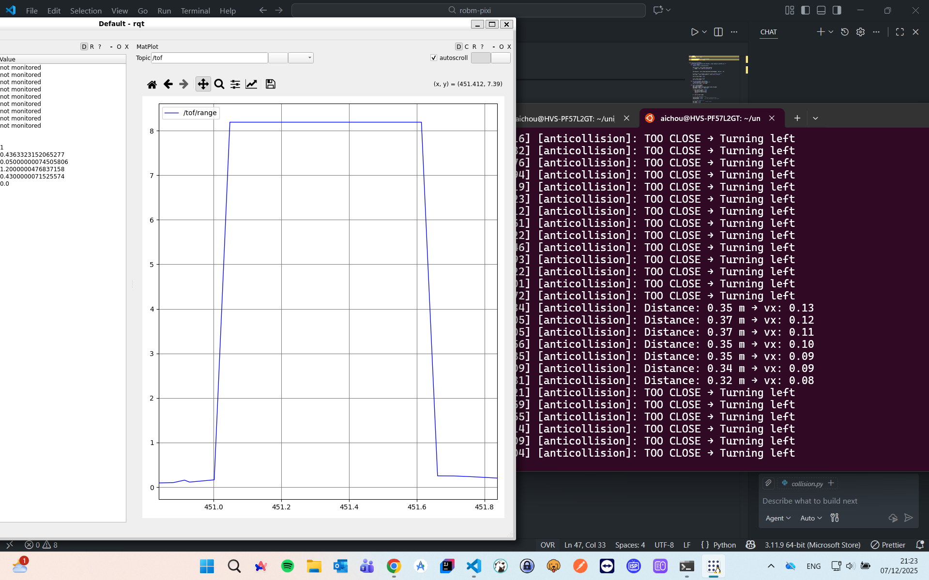

Robot movement

### Stop when facing the green color

ros2 run robm_tp3_roomba dock

import rclpy  
from rclpy.node import Node  
from geometry_msgs.msg import TwistStamped  
from robm_interfaces.msg import Color  
import numpy as np  
  
class AutoDock(Node):  
 """Node to stop the robot on green base using color detection."""  
  
 def __init__(self):  
 super().__init__('auto_dock')  
  
 # Subscribe to the color sensor  
 self.sub_color = self.create_subscription(Color, 'color', self.color_callback, 10)  
  
 # Publisher for robot velocity  
 self.pub_vel = self.create_publisher(TwistStamped, 'cmd_vel', 10)  
  
 # Timer for periodic velocity commands  
 timer_period = 0.2 # 5 Hz for slower updates  
 self.timer = self.create_timer(timer_period, self.timer_callback)  
  
 # Current color reading (r,g,b)  
 self.current_color = np.array([0.0, 0.0, 0.0])  
  
 # Green base RGB measured earlier  
 self.green_ref = np.array([7.31, 30.83, 12.60])  
 self.tolerance = 8.0 # Increase tolerance so it stops earlier  
  
 self.forward_speed = 0.05 # slower speed  
  
 self.get_logger().info("AutoDock node started (slower, safer).")  
  
 def color_callback(self, msg):  
 """Update current color reading."""  
 self.current_color = np.array([msg.r, msg.g, msg.b])  
  
 def timer_callback(self):  
 """Publish velocity based on color."""  
 cmd = TwistStamped()  
 cmd.header.stamp = self.get_clock().now().to_msg()  
 cmd.header.frame_id = 'base_link'  
  
 # Compute distance to green reference  
 dist = np.linalg.norm(self.current_color - self.green_ref)  
  
 if dist < self.tolerance:  
 # Green detected → stop  
 cmd.twist.linear.x = 0.0  
 cmd.twist.angular.z = 0.0  
 self.get_logger().info("Green base detected → STOP")  
 else:  
 # Move forward slowly  
 cmd.twist.linear.x = self.forward_speed  
 cmd.twist.angular.z = 0.0  
 self.get_logger().info(f"Moving forward | dist to green: {dist:.2f}")  
  
 self.pub_vel.publish(cmd)  
  
  
def main(args=None):  
 rclpy.init(args=args)  
 node = AutoDock()  
 rclpy.spin(node)  
 node.destroy_node()  
 rclpy.shutdown()  
  
  
if __name__ == "__main__":  
 main()

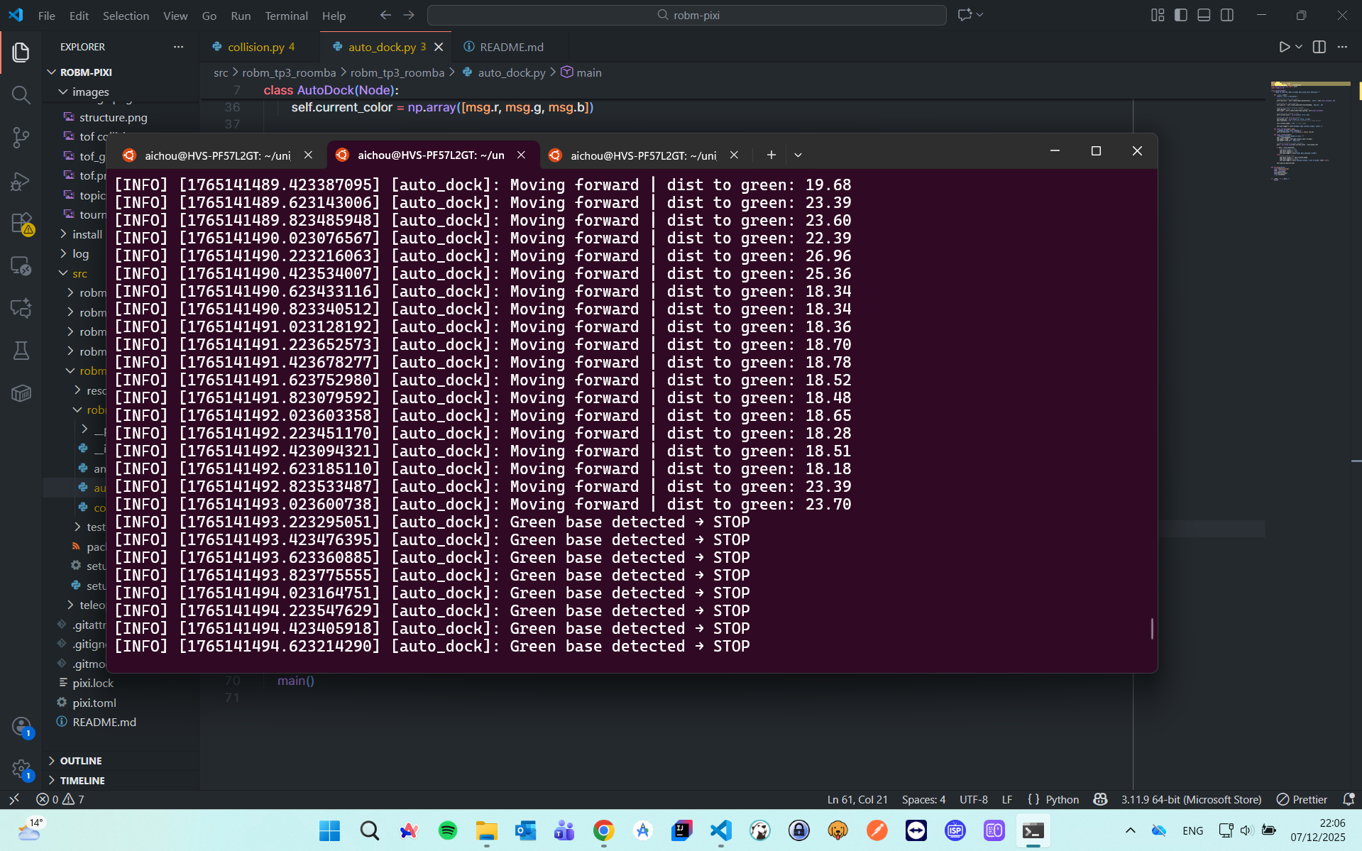

Robot movement

### Stop when almost fallling down

ros2 run robm_tp3_roomba fall

import rclpy  
from rclpy.node import Node  
from geometry_msgs.msg import TwistStamped  
from robm_interfaces.msg import Color  
import numpy as np  
  
class AntiFall(Node):  
 """Anti-fall node using color detection with precise left turn."""  
  
 def __init__(self):  
 super().__init__('anti_fall')  
  
 # Subscribe to color sensor  
 self.sub_color = self.create_subscription(Color, 'color', self.color_callback, 10)  
  
 # Publisher for robot velocity  
 self.pub_vel = self.create_publisher(TwistStamped, 'cmd_vel', 10)  
  
 # Timer for main loop (10 Hz)  
 self.timer = self.create_timer(0.1, self.timer_callback)  
  
 # Current color  
 self.current_color = np.array([0.0, 0.0, 0.0])  
  
 # Floor reference (set to your safe floor color)  
 self.floor_ref = np.array([8.0, 16.0, 27.0])  
 self.tolerance = 10.0 # increase for earlier detection  
  
 # Speeds  
 self.forward_speed = 0.05  
 self.reverse_speed = -0.15  
 self.turn_speed = 0.5 # rad/s  
  
 # State machine: 'startup', 'forward', 'reverse', 'turn'  
 self.state = 'startup'  
 self.state_counter = 0 # counts timer ticks in current state  
  
 # Grace period before checking for cliff (1 sec at 10 Hz)  
 self.startup_ticks = 10  
  
 # Turn duration in ticks for 90° turn  
 self.turn_ticks = int((np.pi / 2) / self.turn_speed * 10) # 10 Hz timer  
  
 def color_callback(self, msg):  
 self.current_color = np.array([msg.r, msg.g, msg.b])  
  
 def timer_callback(self):  
 cmd = TwistStamped()  
 cmd.header.stamp = self.get_clock().now().to_msg()  
 cmd.header.frame_id = 'base_link'  
  
 dist = np.linalg.norm(self.current_color - self.floor_ref)  
  
 if self.state == 'startup':  
 # Initial grace period: just go forward without checking  
 cmd.twist.linear.x = self.forward_speed  
 cmd.twist.angular.z = 0.0  
 self.state_counter += 1  
 if self.state_counter >= self.startup_ticks:  
 self.state = 'forward'  
 self.state_counter = 0  
 self.get_logger().info("Startup complete. Edge detection active.")  
  
 elif self.state == 'forward':  
 if dist > self.tolerance:  
 # Detected cliff → switch to reverse  
 self.state = 'reverse'  
 self.state_counter = 0  
 self.get_logger().info("Edge detected! Reversing...")  
 cmd.twist.linear.x = self.reverse_speed  
 cmd.twist.angular.z = 0.0  
 else:  
 cmd.twist.linear.x = self.forward_speed  
 cmd.twist.angular.z = 0.0  
  
 elif self.state == 'reverse':  
 # Reverse for ~0.5 sec (5 ticks at 10Hz)  
 if self.state_counter < 5:  
 cmd.twist.linear.x = self.reverse_speed  
 cmd.twist.angular.z = 0.0  
 else:  
 # After reversing, start turning left  
 self.state = 'turn'  
 self.state_counter = 0  
 self.get_logger().info("Turning left 90°...")  
 cmd.twist.linear.x = 0.0  
 cmd.twist.angular.z = self.turn_speed # positive = left  
  
 elif self.state == 'turn':  
 if self.state_counter < self.turn_ticks:  
 cmd.twist.linear.x = 0.0  
 cmd.twist.angular.z = self.turn_speed  
 else:  
 # Finished turn → resume forward  
 self.state = 'forward'  
 self.state_counter = 0  
 cmd.twist.linear.x = self.forward_speed  
 cmd.twist.angular.z = 0.0  
 self.get_logger().info("Resuming forward movement.")  
  
 # Only increment state_counter for reverse/turn states  
 if self.state not in ['startup', 'forward']:  
 self.state_counter += 1  
  
 self.pub_vel.publish(cmd)  
  
  
def main(args=None):  
 rclpy.init(args=args)  
 node = AntiFall()  
 rclpy.spin(node)  
 node.destroy_node()  
 rclpy.shutdown()  
  
  
if __name__ == "__main__":  
 main()

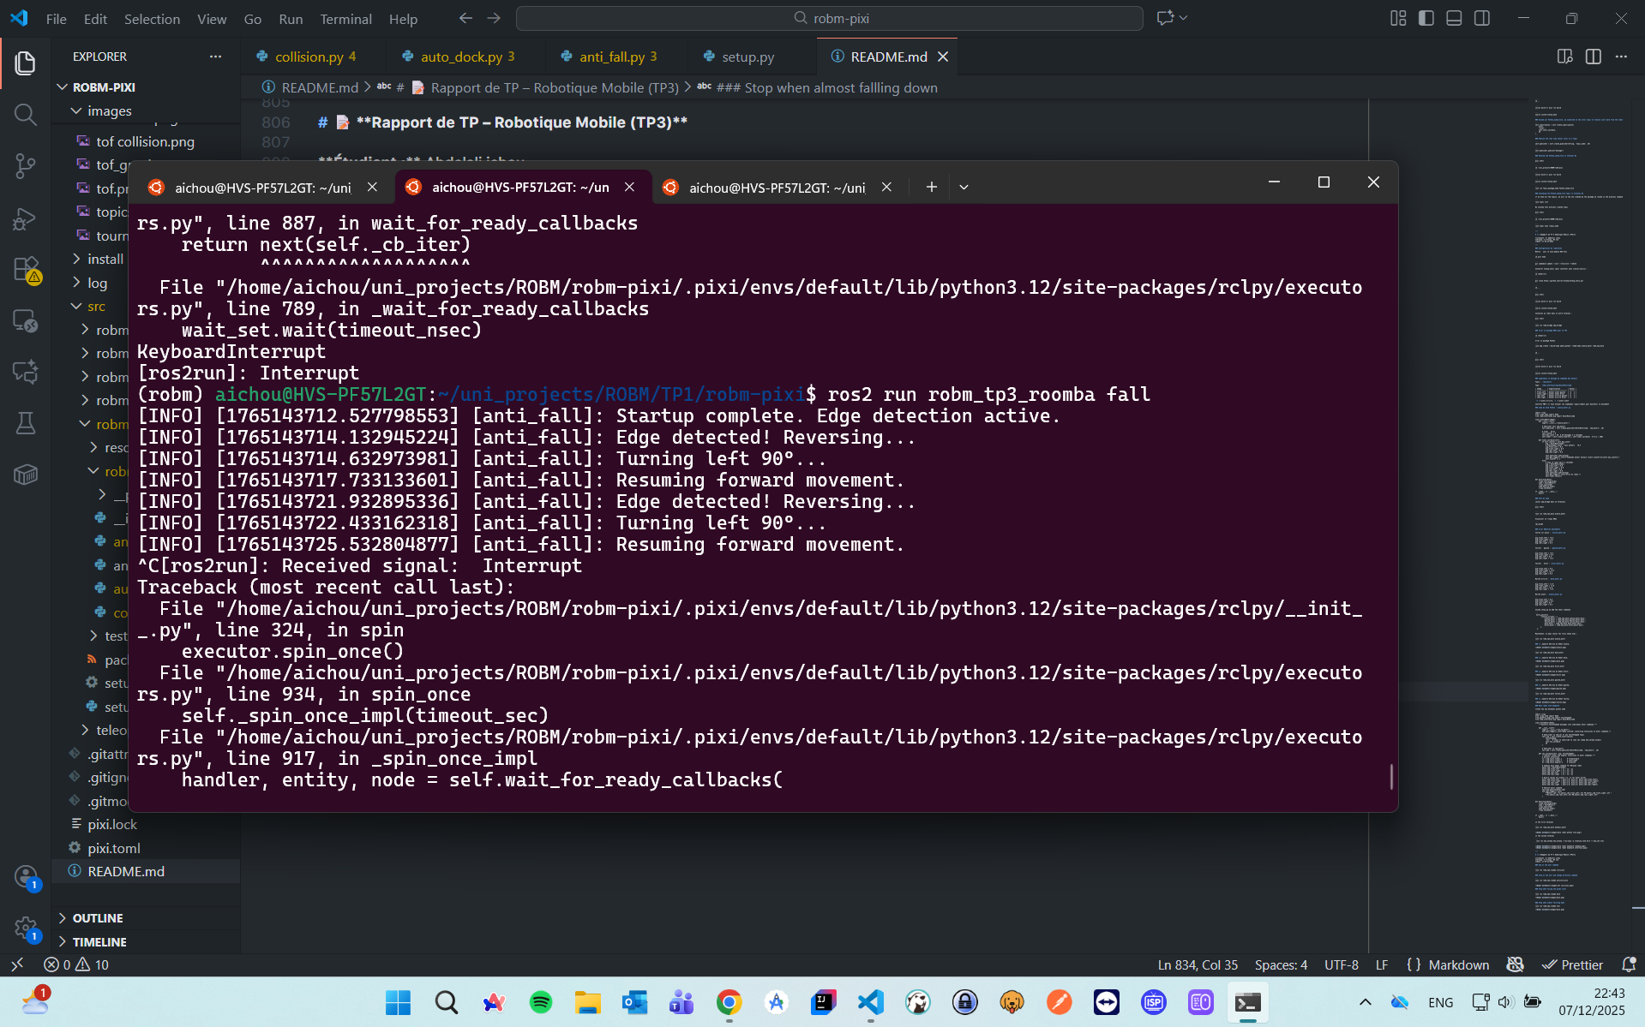

Robot movement

### Robot nettoyeur with all what we’ve done before

ros2 run robm_tp3_roomba cleaner

import rclpy  
from rclpy.node import Node  
from geometry_msgs.msg import TwistStamped  
from robm_interfaces.msg import Color  
import numpy as np  
  
class SpiralClean(Node):  
 """Robot nettoyeur: forward, anti-fall, auto dock, spiral red patches."""  
  
 def __init__(self):  
 super().__init__('spiral_clean')  
  
 # Color sensor subscription  
 self.sub_color = self.create_subscription(Color, 'color', self.color_callback, 10)  
  
 # Velocity publisher  
 self.pub_vel = self.create_publisher(TwistStamped, 'cmd_vel', 10)  
  
 # Timer (10 Hz)  
 self.timer = self.create_timer(0.1, self.timer_callback)  
  
 # Current color  
 self.current_color = np.array([0.0, 0.0, 0.0])  
  
 # References  
 self.floor_ref = np.array([8.0, 16.0, 27.0])  
 self.green_ref = np.array([7.31, 30.83, 12.60])  
 self.red_ref = np.array([48.0, 6.90, 8.94])  
  
 # Tolerances  
 self.floor_tol = 10.0  
 self.green_tol = 8.0  
 self.red_tol = 12.0  
  
 # Speeds  
 self.forward_speed = 0.05  
 self.reverse_speed = -0.15  
 self.turn_speed = 0.5  
 self.spiral_linear_speed = 0.04  
 self.spiral_angular_speed = 0.3  
  
 # State machine  
 self.state = 'startup'  
 self.state_counter = 0  
 self.startup_ticks = 10  
 self.turn_ticks = int((np.pi / 2) / self.turn_speed * 10)  
 self.spiral_ticks = 50 # ~5 sec spiral at 10 Hz  
  
 def color_callback(self, msg):  
 self.current_color = np.array([msg.r, msg.g, msg.b])  
  
 def timer_callback(self):  
 cmd = TwistStamped()  
 cmd.header.stamp = self.get_clock().now().to_msg()  
 cmd.header.frame_id = 'base_link'  
  
 # Compute distances  
 dist_floor = np.linalg.norm(self.current_color - self.floor_ref)  
 dist_green = np.linalg.norm(self.current_color - self.green_ref)  
 dist_red = np.linalg.norm(self.current_color - self.red_ref)  
  
 # ---------------------  
 # STATE MACHINE  
 # ---------------------  
 if self.state == 'startup':  
 # Move forward at start  
 cmd.twist.linear.x = self.forward_speed  
 cmd.twist.angular.z = 0.0  
 self.state_counter += 1  
 if self.state_counter >= self.startup_ticks:  
 self.state = 'forward'  
 self.state_counter = 0  
 self.get_logger().info("Startup complete. Normal operation.")  
  
 elif self.state == 'forward':  
 # Priority order: red patch → green base → edge → normal forward  
 if dist_red < self.red_tol:  
 self.state = 'spiral'  
 self.state_counter = 0  
 self.get_logger().info("Red patch detected! Starting spiral.")  
 cmd.twist.linear.x = self.spiral_linear_speed  
 cmd.twist.angular.z = self.spiral_angular_speed  
  
 elif dist_green < self.green_tol:  
 self.state = 'stop'  
 self.get_logger().info("Green base detected! Stopping.")  
 cmd.twist.linear.x = 0.0  
 cmd.twist.angular.z = 0.0  
  
 elif dist_floor > self.floor_tol:  
 self.state = 'reverse'  
 self.state_counter = 0  
 self.get_logger().info("Edge detected! Reversing...")  
 cmd.twist.linear.x = self.reverse_speed  
 cmd.twist.angular.z = 0.0  
  
 else:  
 cmd.twist.linear.x = self.forward_speed  
 cmd.twist.angular.z = 0.0  
  
 elif self.state == 'reverse':  
 if self.state_counter < 5:  
 cmd.twist.linear.x = self.reverse_speed  
 cmd.twist.angular.z = 0.0  
 else:  
 self.state = 'turn'  
 self.state_counter = 0  
 self.get_logger().info("Turning left 90°...")  
 cmd.twist.linear.x = 0.0  
 cmd.twist.angular.z = self.turn_speed  
  
 elif self.state == 'turn':  
 if self.state_counter < self.turn_ticks:  
 cmd.twist.linear.x = 0.0  
 cmd.twist.angular.z = self.turn_speed  
 else:  
 self.state = 'forward'  
 self.state_counter = 0  
 self.get_logger().info("Turn complete. Resuming forward.")  
 cmd.twist.linear.x = self.forward_speed  
 cmd.twist.angular.z = 0.0  
  
 elif self.state == 'spiral':  
 if self.state_counter < self.spiral_ticks:  
 cmd.twist.linear.x = self.spiral_linear_speed  
 cmd.twist.angular.z = self.spiral_angular_speed  
 else:  
 self.state = 'forward'  
 self.state_counter = 0  
 self.get_logger().info("Spiral complete. Resuming forward.")  
 cmd.twist.linear.x = self.forward_speed  
 cmd.twist.angular.z = 0.0  
  
 elif self.state == 'stop':  
 cmd.twist.linear.x = 0.0  
 cmd.twist.angular.z = 0.0  
  
 # Increment counters for timed states  
 if self.state in ['reverse', 'turn', 'spiral']:  
 self.state_counter += 1  
  
 # Publish command  
 self.pub_vel.publish(cmd)  
  
  
def main(args=None):  
 rclpy.init(args=args)  
 node = SpiralClean()  
 rclpy.spin(node)  
 node.destroy_node()  
 rclpy.shutdown()  
  
  
if __name__ == "__main__":  
 main()

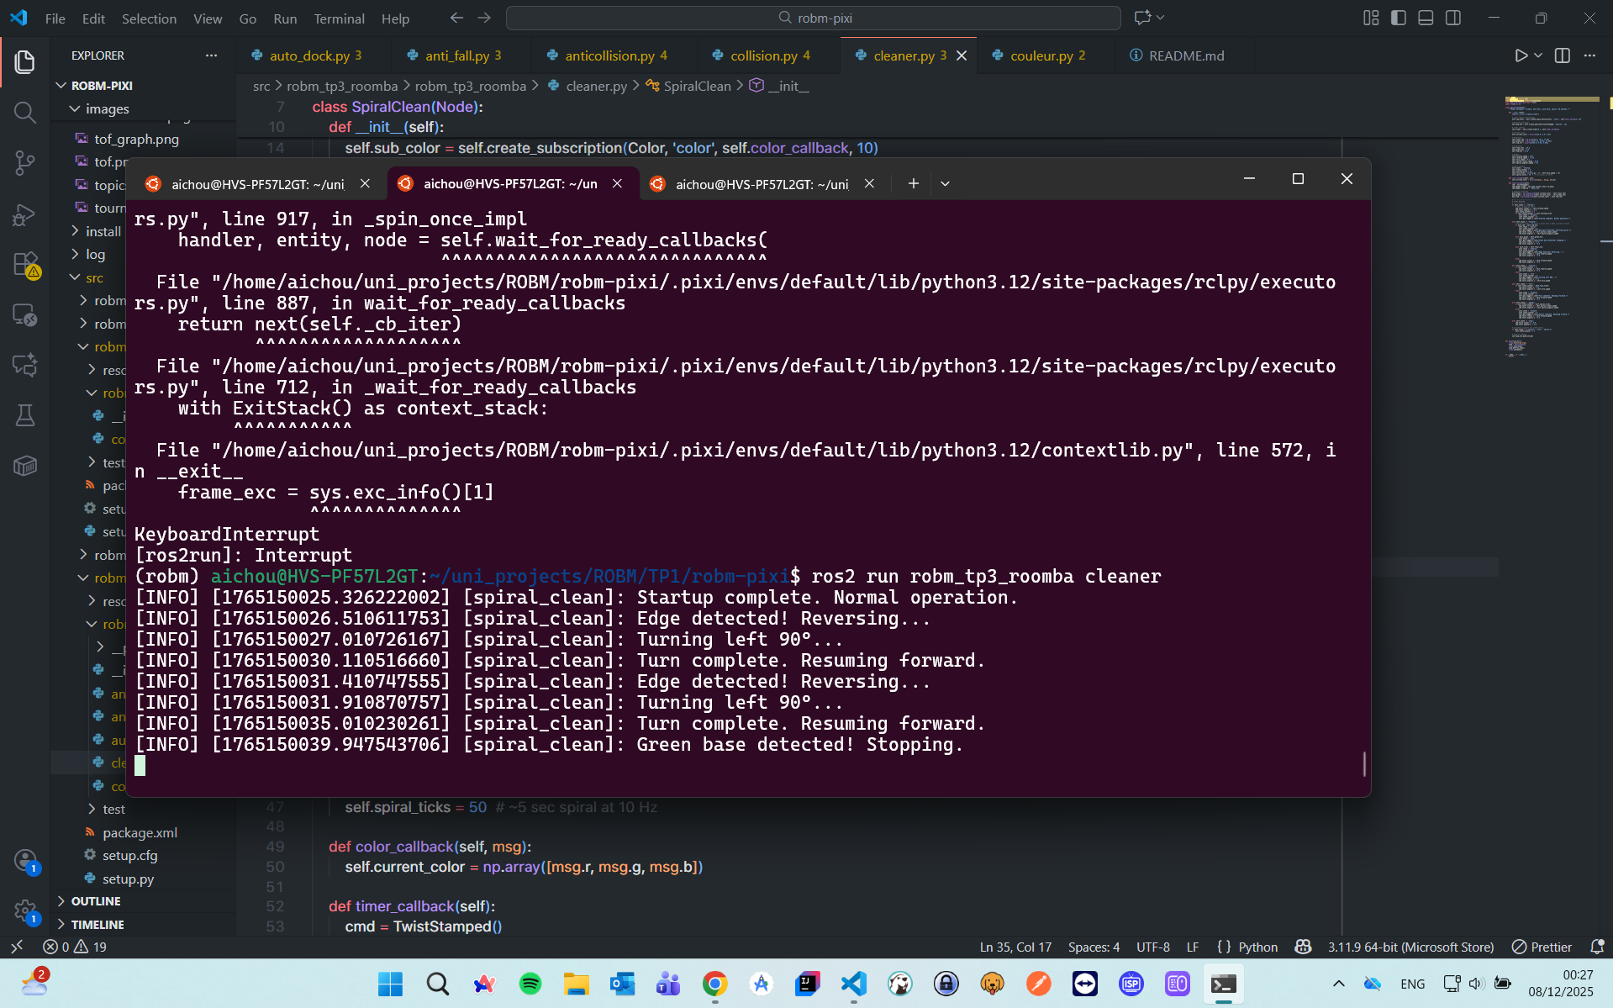

Robot movement